Practical 01 – Components of Personal Computer

Learning Outcomes
In this practical, learners will explore the internal components of a personal computer by examining motherboard images and using system tools to gather hardware and network information. Through this hands-on activity, learners will develop a clearer understanding of how key components function individually and work together to support overall system performance. By the end of the practical, learners will be able to:
- Identify key components on a motherboard, including CPU, CPU cache, memory, and NIC.
- Understand the basic functions of each component in a computer system.
- Use system tools to view hardware and network information.
- Recognise different types of memory and network interfaces.
- Apply basic skills to examine and categorise computer hardware components.

Software and Tools Used in Practical
No. | Tools | Description
1. | System Information (msinfo32.exe) | Viewing of system architecture and CPU information.
2. | Web browser (Microsoft Edge / Google Chrome) and stable internet connection. | Finding full CPU specifications on official manufacturer websites.
3. | Task Manager (taskmgr.exe) | Shows running processes and system performance metrics, including memory, speed and slot usage.
4. | Command Prompt (ipconfig.exe) | Utility used for retrieving network information like NIC model, IP and MAC address.
5. | Any AI Tools such as ChatGPT, Gemini, Co-Pilot etc. | To assist or support the learners to find suitable information pertaining to the practical.

Practical Exercise

Exercise 1.1 Identifying the CPU on a Motherboard.
- Refer to the image below, are you able to identify the CPU socket(s)?
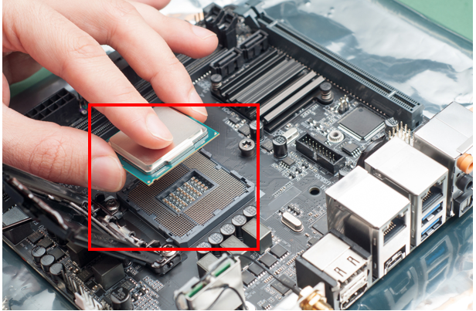

- To prevent overheating, a special paste is applied on top of the CPU.
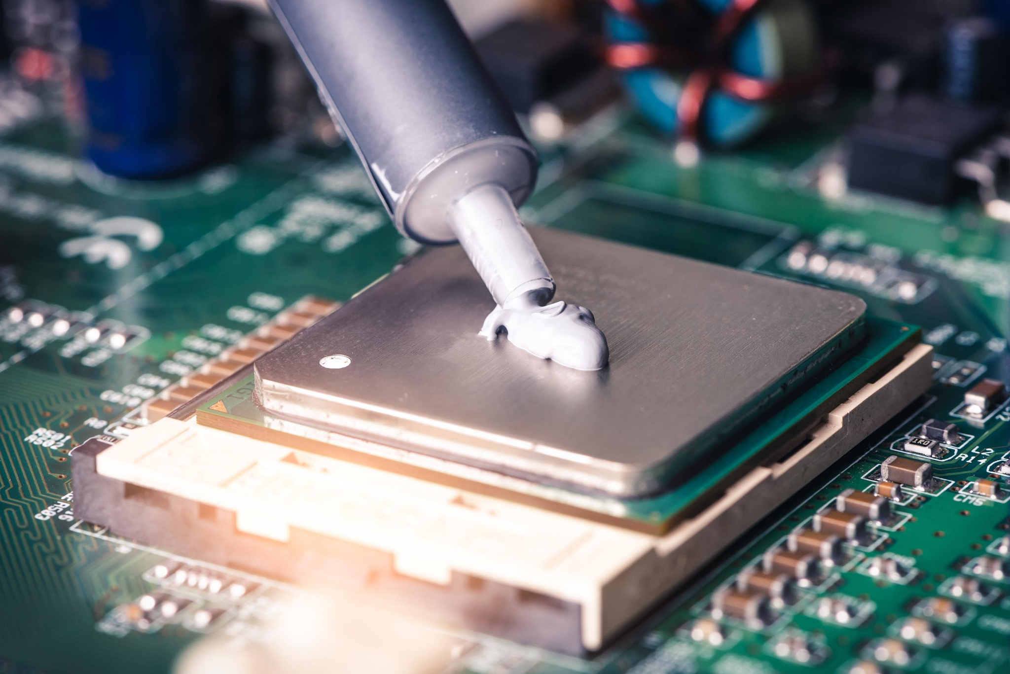

Question: What is the name of the paste applied to the CPU? (You may use AI tools to assist you in finding the answers.)
Thermal paste

- To find the processor model of a Windows computer, type “System Information” in the search bar next to the Windows icon and open the application. In the System Information window, look for the processor model (model number) under the System Summary. This tool provides an overview of your computer’s hardware and software, including components such as the CPU, RAM, storage, and operating system.
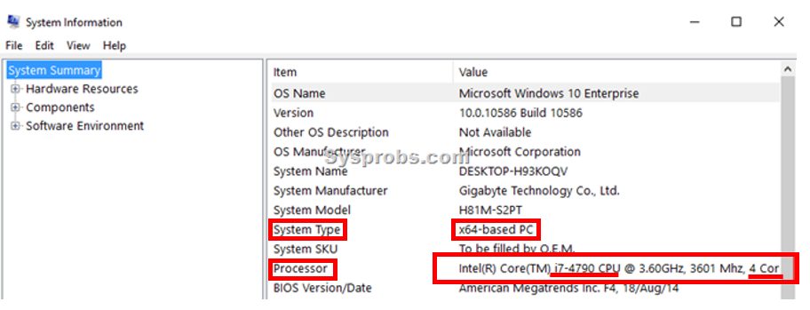
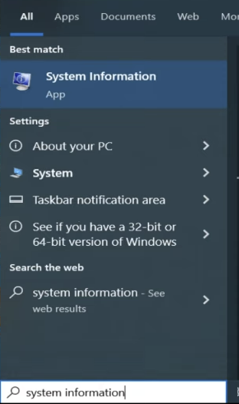

Question: Based on the system information page you see, fill in the table below.
System Type (32bit or 64bit) | 64bit
Processor Model | Intel Core i5-6300U
Number of CPU Cores | 4

Exercise 1.2 CPU Cache
- Based on the model of the processor in the previous step, visit https://www.intel.com/content/www/us/en/search.html or https://www.amd.com/en/search/site-search.html. These are the two common CPU manufacturers. Search for your CPU to get more information about technologies supported and socket type for motherboard compatibility. When selecting a laptop, the CPU can be considered the “brain” of the system. Choosing the right processor depends on your intended usage. For basic tasks such as web browsing, document editing, and learning activities, an energy-efficient CPU is recommended, as it helps reduce battery consumption while still delivering sufficient performance.

Instructions for searching Intel CPU (https://www.intel.com/content/www/us/en/search.html).
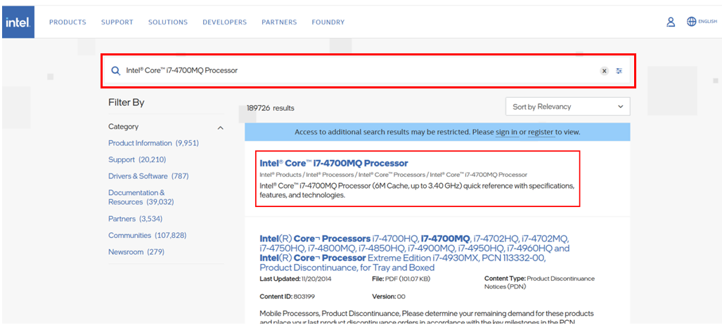
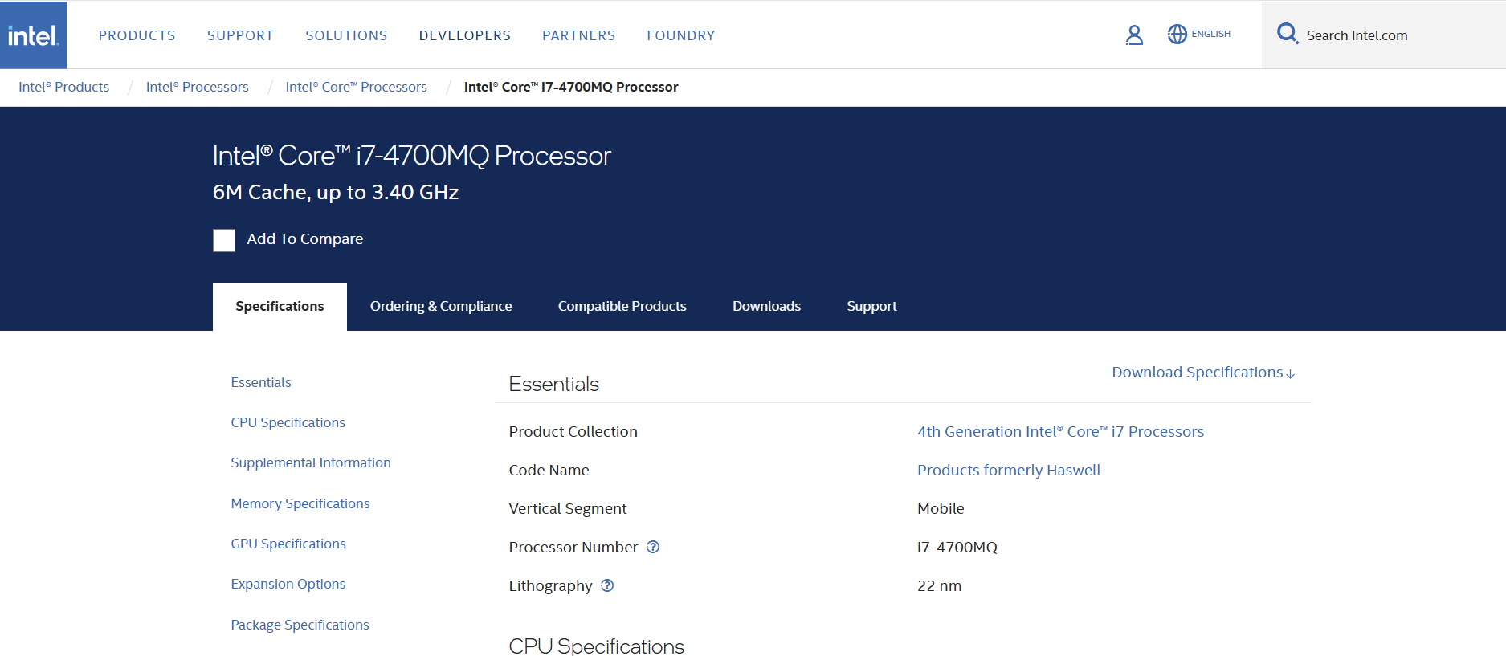

Instructions for AMD CPU (https://www.amd.com/en/search/site-search.html).

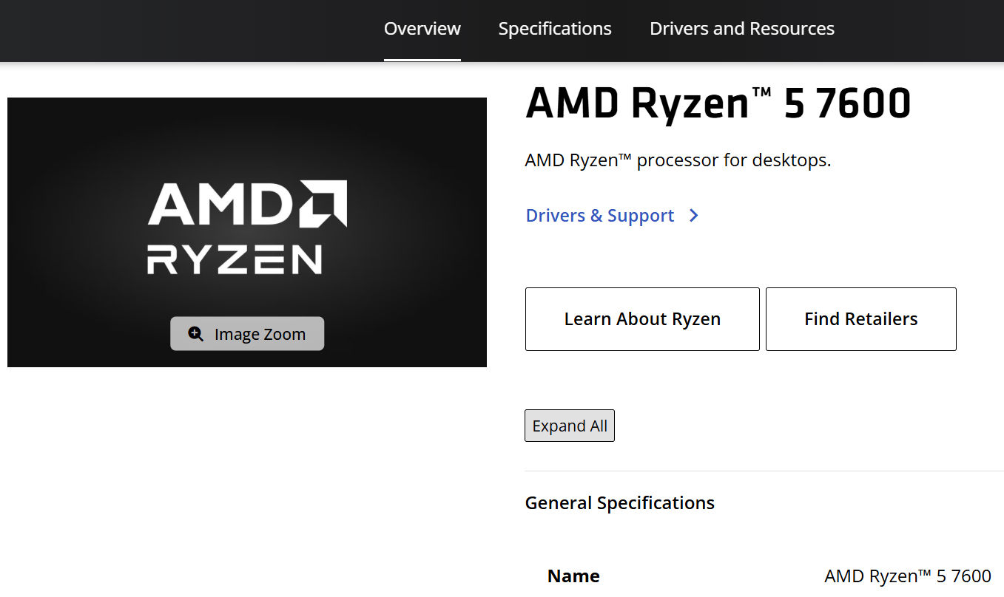
- Check the CPU Cache size by pressing Ctrl + Shift + Esc, which launches task manager. To learn more about CPU Cache, watch this video https://youtu.be/yi0FhRqDJfo?si=vDDroA8xJrnaSgsv .
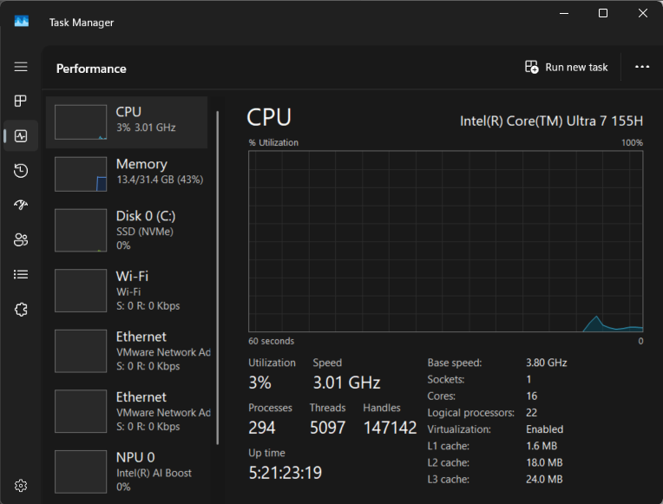

Question: Using the information from your computer’s Task Manager, record the size of your L1, L2, and L3 cache.
L1 Cache | 128 KB
L2 Cache | 512 KB
L3 Cache | 3.0 MB

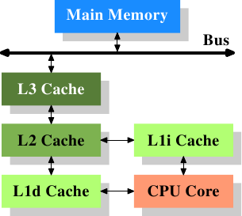

L1 Cache (Level 1): The smallest and fastest cache located closest to the CPU core. It stores frequently used instructions (L1i) and data (L1d) for immediate access, enabling very high-speed processing.
L2 Cache (Level 2): Larger than L1 but slightly slower. It acts as an intermediate layer, storing additional data and instructions that are not found in L1, helping to reduce access time to main memory.
L3 Cache (Level 3): The largest and slowest among the three caches, shared across multiple CPU cores. It stores commonly used data for all cores and helps improve overall system performance by reducing the need to access main memory.

Question: Explain how CPU cache improves computer performance.
(You may use AI tools to assist you in finding the answers.)
CPU cache improves computer performance by reducing the time it takes the processor to access data and instructions. Below is a clear, step-by-step explanation of how this works and why it matters.

Exercise 1.3 Identifying the Memory of your own Personal Computer
- Observe the 3D image of the RAM https://sketchfab.com/3d-models/random-access-memory-ram-ddr3-d2715d60f139421eb6028efd5153fdaf. Start Task Manager by pressing the Ctrl + Shift + Esc keys and write down the size of memory. Watch this short video to learn about RAM https://youtu.be/dgMeWRy84l8?si=3Gh8Hs9ap0S5pOxq.
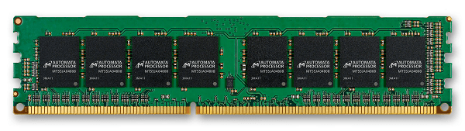
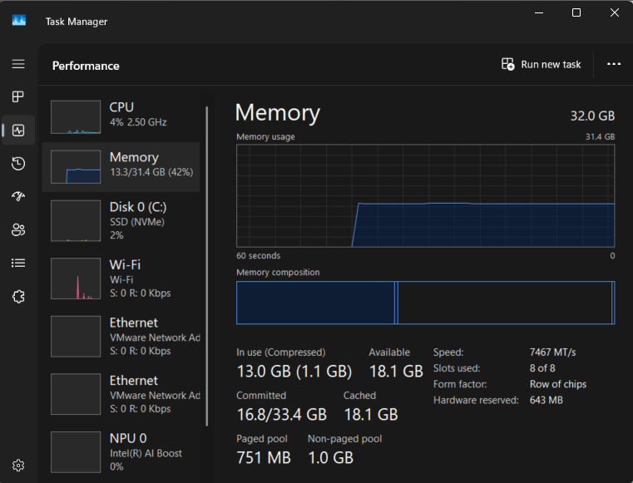

Question: Using the information from your computer’s Task Manager, record the size of your physical memory (RAM).
Size of Physical Memory (RAM) | 8 GB

Physical Memory (RAM)
The amount of RAM (in gigabytes, GB) determines how many applications your computer can run smoothly at the same time. Modern systems require higher memory to support current operating systems, web applications, and multitasking needs.
- 4–8 GB: Suitable for basic tasks such as web browsing, document editing, and light applications. However, performance may slow down with multiple applications or many browser tabs open.
- 8–16 GB: Recommended for most users. Supports multitasking, multimedia usage, and light gaming comfortably without significant slowdowns.
- 16–32 GB: Ideal for power users such as gamers, developers, and content creators working with video editing, design tools, or virtual machines.
- 32 GB and above: Designed for advanced workloads such as high-end gaming, large-scale data processing, professional video production, and heavy virtualisation.
RAM Speed
RAM speed is measured in Megahertz (MHz) or Mega Transfers per second (MT/s), and indicates how quickly data can be accessed and transferred. Higher RAM speeds improve overall system responsiveness, especially when paired with modern processors.

- RAM upgrades are limited by the capability of the system and the availability of expansion slots for adding RAM.
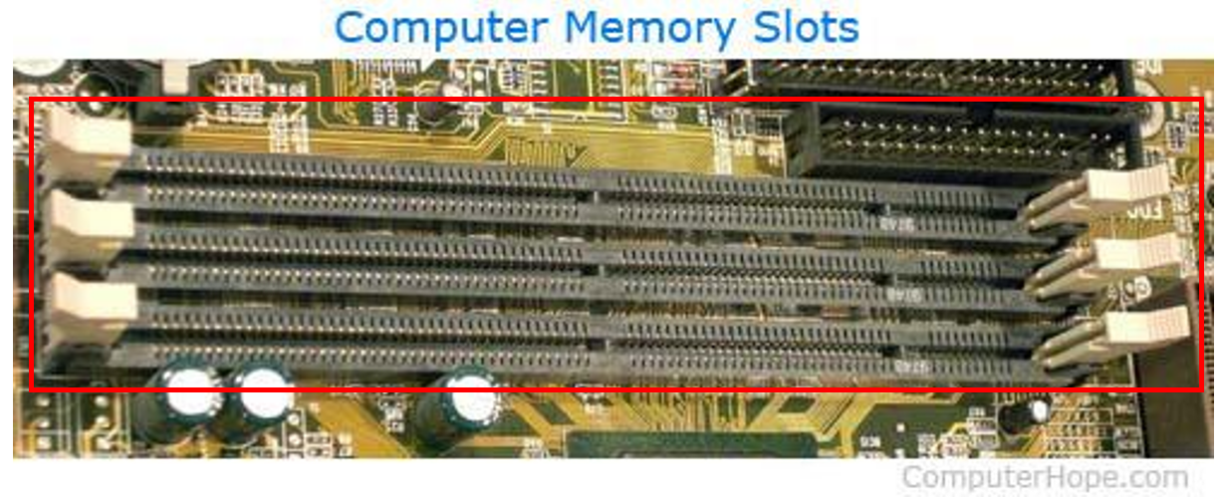
Let us take a closer look at the RAM inserted into the empty slots. The label on the bottom right states DDR4 UDIMM, DDR4 indicates the RAM standard.
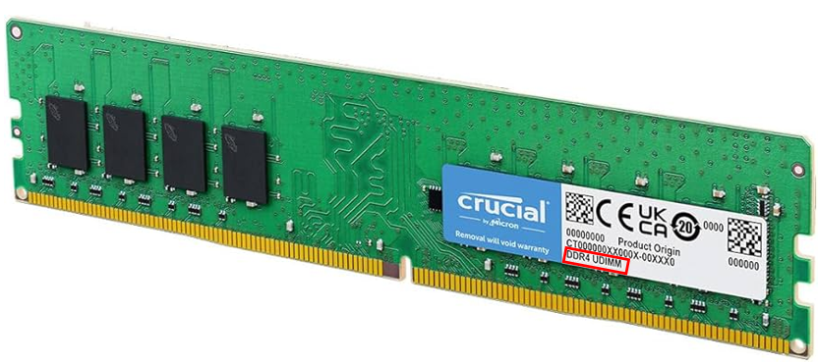
Different Standards of RAM. The main differences between DDR memory types are the number of pins and data rates.
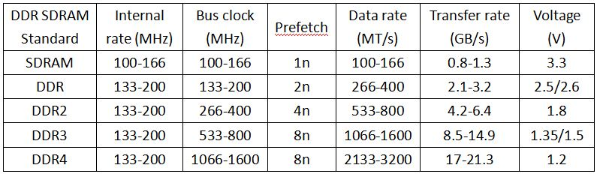
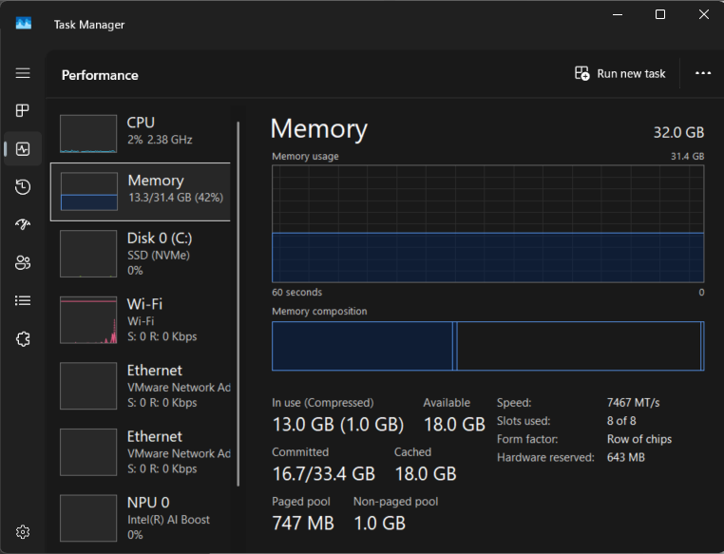

Question: Using the information from your computer’s Task Manager, determine how many memory slots are currently in use.
Slot used: | 2 of 2

Exercise 1.4 Network Interface Card
Ethernet Card
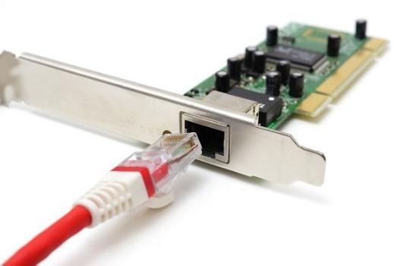
An Ethernet card, also known as a Network Interface Card (NIC), is a hardware component that enables a computer to connect to other devices on the same Ethernet Local Area Network (LAN). Early Ethernet cards were external devices that had to be installed manually. In modern computer systems, the NIC is typically integrated into the motherboard as an internal component. A wired Ethernet NIC includes an RJ45 port, which allows a network cable to be physically connected, providing a stable and reliable network connection.
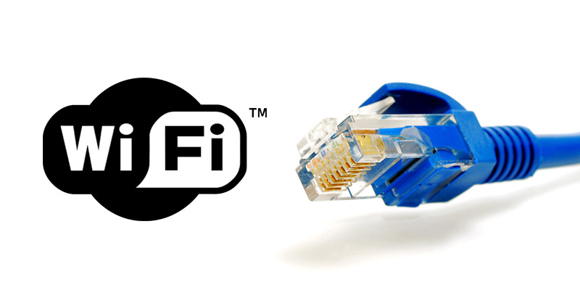

- Open Command Prompt by pressing Win + R to launch Run, then type cmd and click OK.
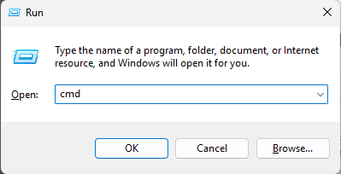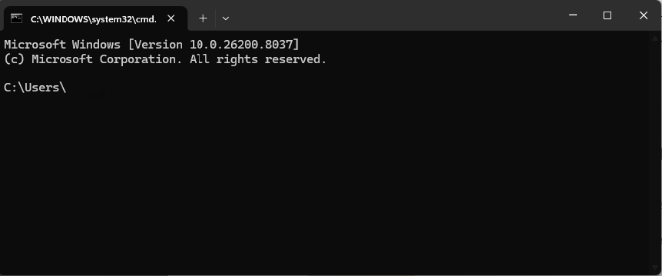

- Type in the following command.
ipconfig /all
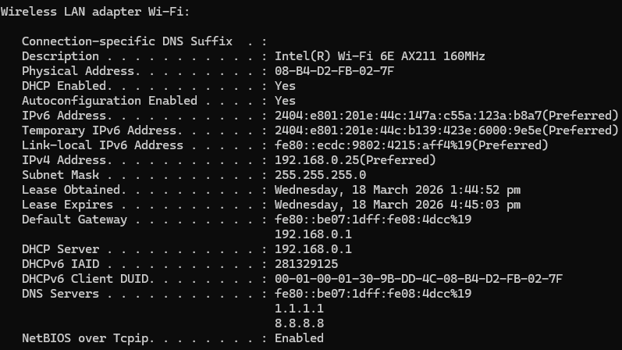1
Question: Using the output from the ipconfig /all command in Command Prompt, record the relevant network information.
Wireless NIC Information

Model | Marvell AVASTAR Wireless-AC Network Controller
IP address | 172.22.74.198(Preferred)
MAC Address | BC-83-85-C9-1A-BC
Default Gateway | 172.22.72.1
DNS Servers | 172.25.25.111  172.25.25.112

- Based on the model of the Wireless Network Interface Card, find an image of your NIC online.
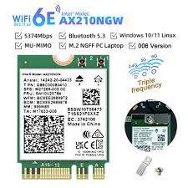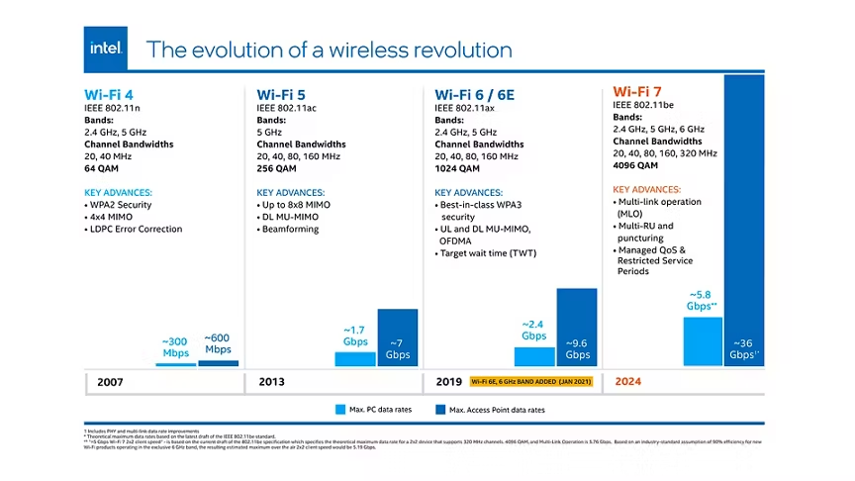

Exercise 1.5 Reflection question
Question: What does MAC address stand for, and how many bytes does a MAC address contain? (You may use AI tools to assist you in finding the answers.)
MAC address stands for Media Access Control address.
How many bytes does a MAC address contain?
A standard MAC address contains 6 bytes.
Additional details (for clarity):
- 6 bytes = 48 bits
- Written commonly as six pairs of hexadecimal digits
Example: 00:1A:2B:3C:4D:5E
- Used to uniquely identify a network interface (such as Ethernet or Wi-Fi) at the data link layer (Layer 2) of the OSI model.

Question: If you replace your Wi-Fi card, will the MAC address change, and which Wi-Fi standards support both 2.4 GHz and 5 GHz frequency bands? (You may use AI tools to assist you in finding the answers.)
1. Will the MAC address change if you replace your Wi-Fi card?
Yes, it usually will.
- A MAC (Media Access Control) address is assigned to a specific network interface, such as a Wi-Fi card.
- When you replace the Wi-Fi card, you are installing new hardware, which comes with its own MAC address, so the MAC address seen by the system changes.
Important notes / exceptions:
- Many operating systems support MAC address spoofing or randomization, so the MAC address shown to networks may be manually set or randomized.
- Virtual adapters (VPNs, virtual machines) can have different MAC addresses that are not tied to physical hardware.

2. Which Wi-Fi standards support both 2.4 GHz and 5 GHz?
The Wi-Fi standards that support both 2.4 GHz and 5 GHz frequency bands are:
- ✅ IEEE 802.11n (Wi-Fi 4)
- ✅ IEEE 802.11ax (Wi-Fi 6 / Wi-Fi 6E*)
* Wi-Fi 6E adds support for 6 GHz but still includes 2.4 GHz and 5 GHz on compatible hardware.

----- End of Practical -----

