Practical 02 – General Computing Concept

Learning Outcomes
In this practical, learners will explore how the CPU, memory, and input/output (I/O) components work together by using the Little Man Computer (LMC) simulator. Through step-by-step execution of simple programs, learners will observe how data is processed, stored, and transferred within a computer system. This hands-on activity helps learners understand the fetch–execute cycle and the interaction between different system components. By the end of the practical, learners will be able to:
- Identify the roles of CPU, memory, and I/O in a computer system.
- Understand how instructions are executed using the fetch–execute cycle.
- Interpret basic LMC instructions such as INP, ADD, SUB, STA, and OUT.
- Observe how data moves between the accumulator, memory, and input/output.

Software and Tools Used in Practical
No. | Tools | Description
1. | LMC Simulator (https://peterhigginson.co.uk/LMC/) | The Little Man Computer (LMC) Simulator is a simple learning tool that helps users understand how a computer works by simulating basic CPU operations, memory usage, and instruction execution in a step-by-step manner.
2. | Web browser (Microsoft Edge / Google Chrome) and stable internet connection. | Finding full CPU specifications on official manufacturer websites.
3. | Any AI Tools such as ChatGPT, Gemini, Co-Pilot etc. | To assist or support the learners to find suitable information pertaining to the practical.

Little Man Computer Simulator
The Little Man Computer (LMC) is a simplified model designed to help learners understand the fundamental principles of how computers operate. It represents a basic computer system using an easy-to-visualise analogy, where a “little man” performs instructions, processes data, and interacts with memory and input/output. Through this model, key concepts such as the accumulator, memory storage, and instruction execution can be clearly demonstrated without the complexity of modern hardware.
The concepts illustrated by the LMC closely reflect the foundations of modern computer architecture, particularly the von Neumann architecture, where instructions and data are stored in the same memory and executed sequentially. In both LMC and real computers, the CPU follows a fetch–decode–execute cycle, retrieving instructions from memory, interpreting them, and performing operations. While modern CPUs are far more advanced, incorporating multiple cores, caches, and parallel processing, they still rely on these same fundamental principles introduced in simple models like the LMC.
Over time, these basic concepts have evolved into the powerful computing systems we use today. Modern computers expand on the LMC model by introducing high-speed memory, advanced instruction sets, and efficient input/output systems, enabling complex applications such as artificial intelligence, cloud computing, and real-time processing. The practical is based on the LMC simulator developed by Peter Higginson using JavaScript, and it will utilise the online simulator (https://peterhigginson.co.uk/LMC/) to help learners understand how computers execute instructions, process data, and interact with memory and input/output in a step-by-step manner. 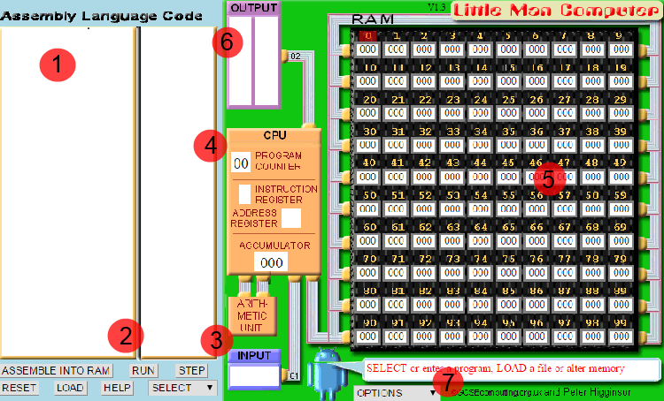
The main components of the LMC simulator interface, as shown in the image, are:
- Code Editor Area – The section where assembly language instructions are entered.
- Control Buttons – Buttons used to load the program into memory and execute it (e.g., Assemble, Run, Step).
- Input Panel – The area where users can provide input values for the program during execution.
- CPU Display Panel – Shows the internal state of the CPU, including the program counter, instruction register, address register, and accumulator, allowing step-by-step tracking of execution.
- Memory (RAM) Grid – A collection of 100 memory locations (00–99) where both instructions and data are stored, following the von Neumann architecture.
- Output Panel – Displays the results produced by the program during execution.
- Execution Controls – Options to control how the program runs, such as adjusting speed or stepping through instructions.
The most effective way to learn the LMC is by running a series of programs, starting from simple ones and gradually progressing to more complex examples, rather than trying to fully understand the simulator at the beginning.
It is also important to become familiar with the instruction set, which is relatively small, consisting of only 11 basic instructions, as shown below:
Mnemonic Code | Numeric Code | Instruction
INP | 901 | Input data
ADD | 1XX | Add the contents of the memory address to the Accumulator
SUB | 2XX | Subtract the contents of the memory address from the Accumulator
STA | 3XX | Store the value in the Accumulator in the memory address given.
LDA | 5XX | Load the Accumulator with the contents of the memory address given
BRA | 6XX | Branch - use the address given as the address of the next instruction
BRZ | 7XX | Branch to the address given if the Accumulator is zero
BRP | 8XX | Branch to the address given if the Accumulator is zero or positive
INP | 901 | Input data
OUT | 902 | Output data
HLT | HLT | Stop (Little Man has a rest).
DAT |  | Used to indicate a location that contains data.

Practical Exercise

Exercise 2.1 Input data, move the data from accumulator to memory
- Copy the following code into LMC simulator (https://peterhigginson.co.uk/LMC/).
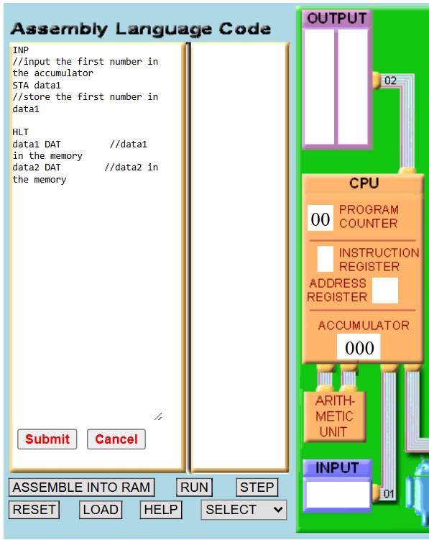
INP
STA data1
HLT
data1 DAT
data2 DAT

Description of the Assembly Code: This program takes a single input from the user and stores it in memory.
- The INP instruction allows the user to enter an integer, which is temporarily placed in the accumulator.
- The STA data1 instruction then stores this value into a memory location labelled data1.
- The program then executes HLT, which stops the program.
- The lines data1 DAT and data2 DAT define reserved memory locations for storing data, although only data1 is used in this program.

- Observe the numeric code generated and loaded into memory by clicking the Submit button.
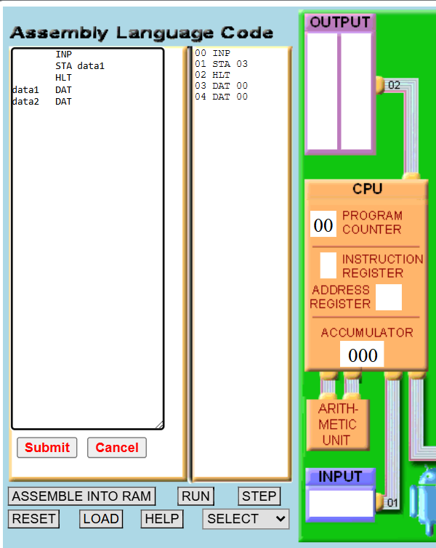
- Run the code by clicking Step. observe the red circle is for memory address, and blue circle is for data, or code.
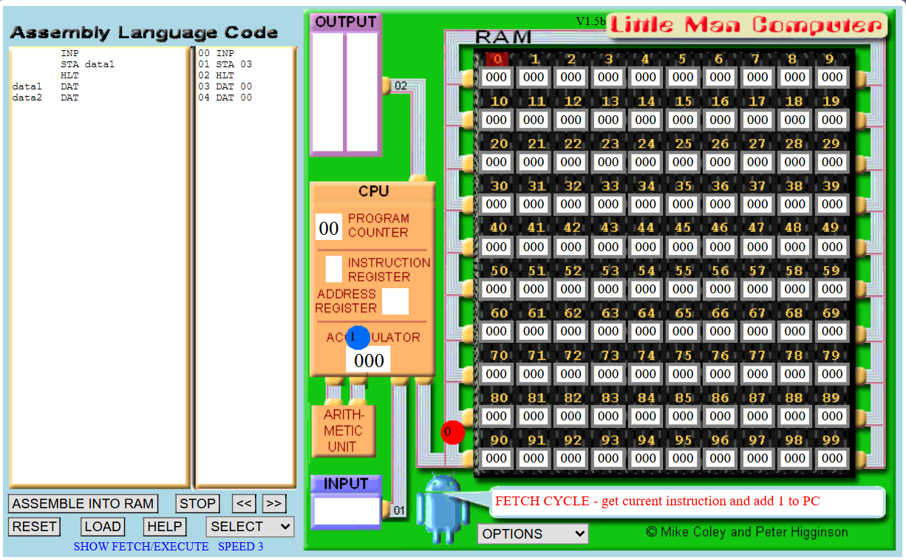

- When LMC Simulator ask for input, you may enter any integer into the input area (Example: enter 8 into the input area) and press Enter key.
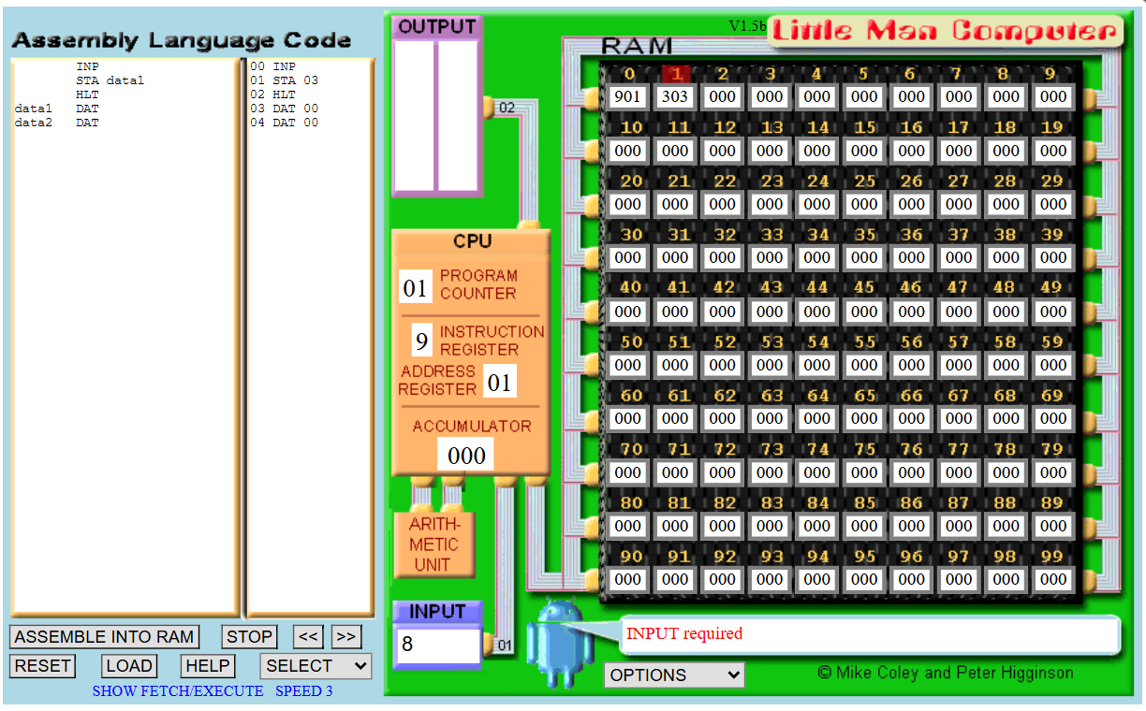
Question: What is the value in the “ACCUMULATOR” area?
008

Question: What is the value in “PROGRAM COUNTER” area?
01

- Click on Step to execute the STA 3 03 (STA data1) to store the value from the “ACCUMLATOR” to memory.
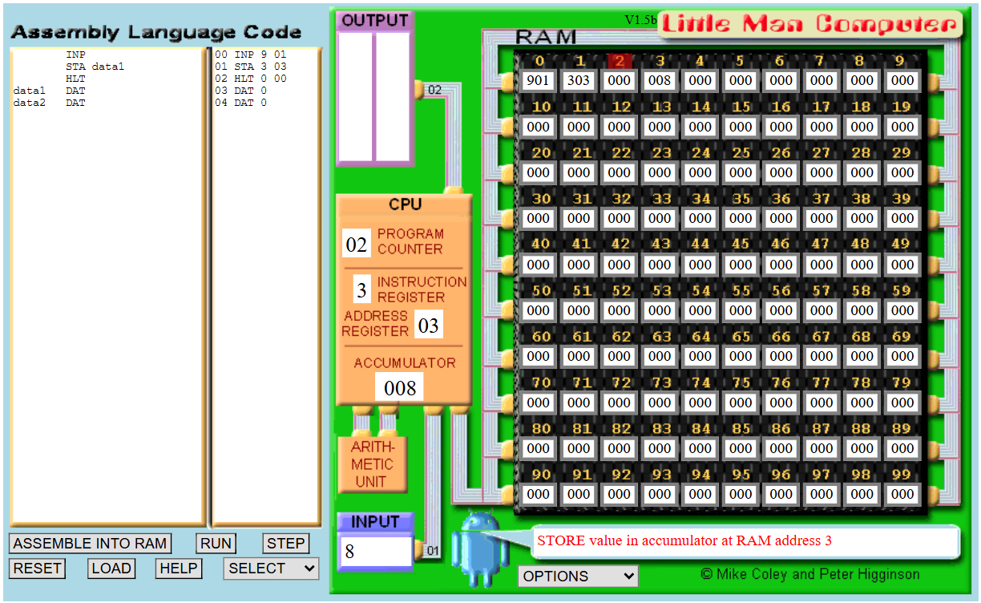
Question: Which memory address is the input being stored?
Answer: 3

- Click on Step to execute the HALT (HLT).
Question: Observe the memory address and fill in the memory address based on the assembly code.
Assembly Code | Numeric Code | Address
INP | 901 | 0
STA | 303 | 1
HLT | 000 | 2
data1 | 8 | 3

Exercise 2.2 Input and Output
- Copy the following code into LMC simulator (https://peterhigginson.co.uk/LMC/).
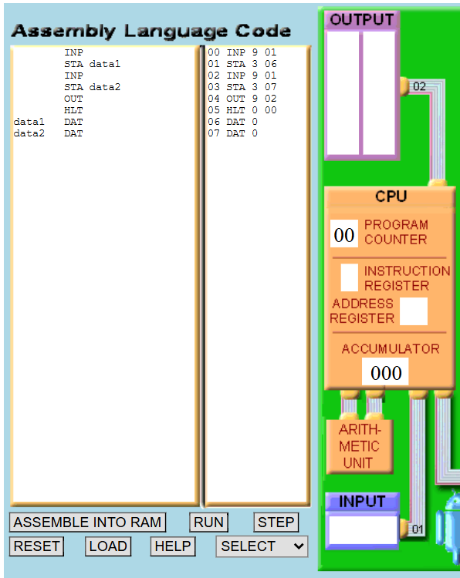
INP
STA data1
INP
STA data2
OUT
HLT
data1 DAT
data2 DAT
Description of the Assembly Code: This program takes two inputs from the user and stores them in memory before displaying a result.
- The first INP instruction reads a value into the accumulator and stores it in data1 using STA data1.
- The second INP reads another value and stores it in data2 using STA data2.
- The OUT instruction then outputs the current value in the accumulator (which is the second input).
- Finally, HLT stops the program.
- The data1 DAT and data2 DAT lines define memory locations used to store the input values.

- This time click on Run to run through the entire code. Enter the 8 as the first input in the input area and the 9 as the second input respectively. (Note: Run executes through the entire code without stopping while Step stops/break after executing each line of the code).
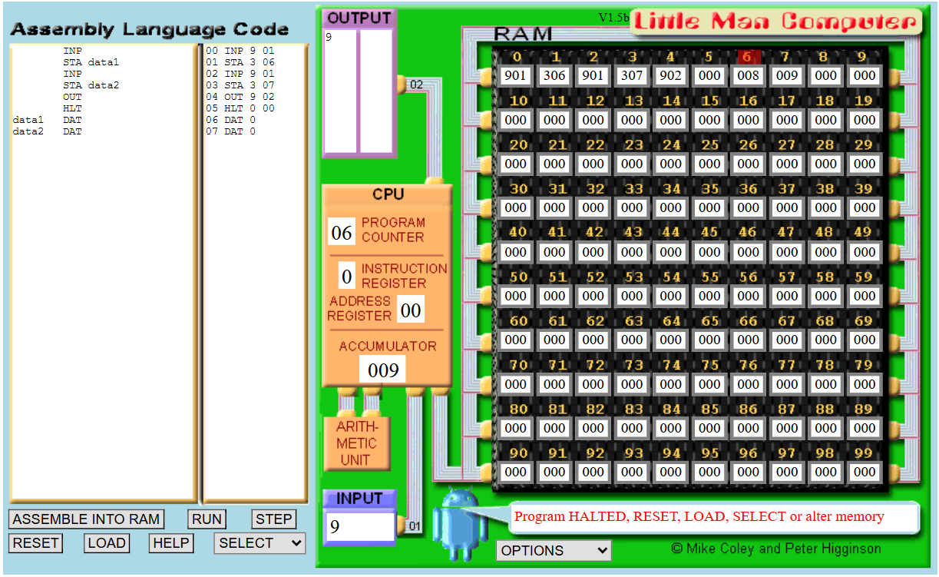

Question: Observe the memory address and fill in the memory address based on the assembly code.
Assembly Code | Numeric Code | Address
INP | 901 | 00
STA | 306, 307 | 01, 03
OUT | 902 | 04
HLT | 000 | 05
data1 | 8 | 06
data2 | 9 | 07

Exercise 2.3 Adding 2 Integers using LMC Simulator
- Copy the following code into LMC simulator (https://peterhigginson.co.uk/LMC/).
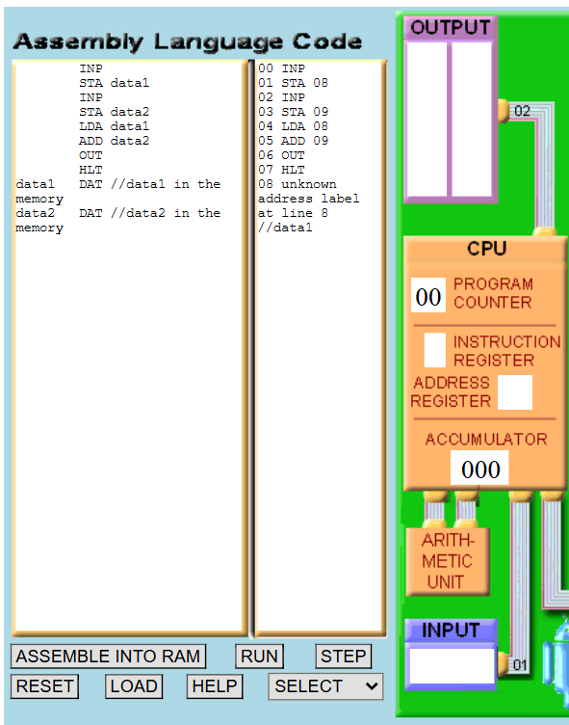
INP
STA data1
INP
STA data2
LDA data1
ADD data2
OUT
HLT
data1 DAT
data2 DAT
Description of the Assembly Code: This program takes two inputs from the user, adds them together, and displays the result.
- The first INP reads a value into the accumulator and stores it in data1 using STA data1.
- The second INP reads another value and stores it in data2 using STA data2.
- The LDA data1 instruction then loads the first value back into the accumulator and ADD data2 adds the second value to it.
- The result is stored in the accumulator and displayed using OUT.
- Finally, HLT stops the program.
- The data1 DAT and data2 DAT define memory locations for storing the input values.

- Run the code to test if it works.

- Observe the memory, register, and output at the end of the execution.
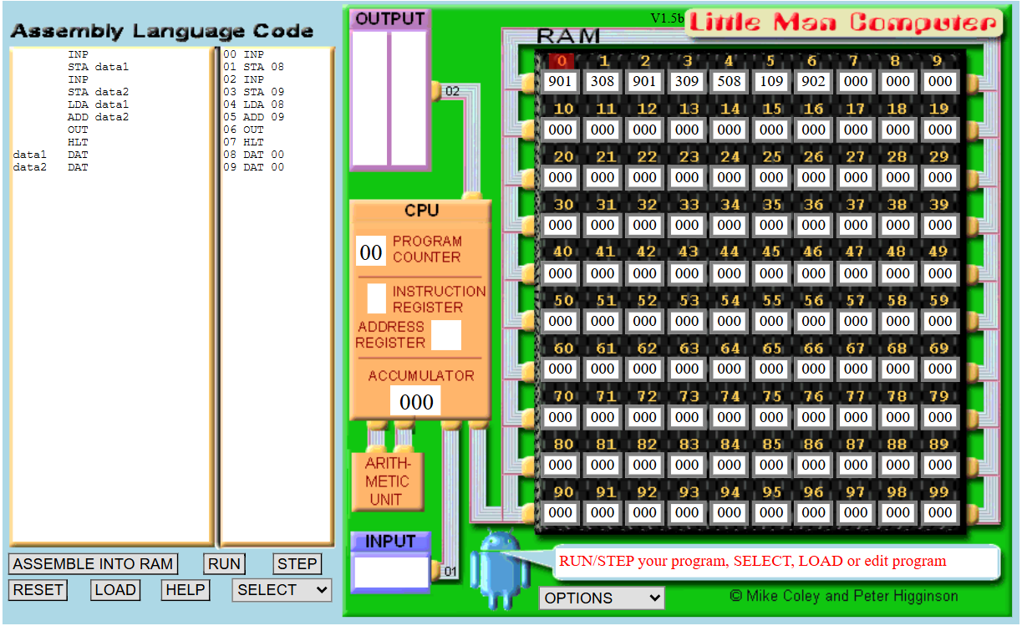

Question: Observe the memory address and fill in the memory address based on the assembly code.
Assembly Code | Numeric Code | Address
INP | 901 | 00
STA | 308 | 01
INP | 901 | 02
STA | 309 | 03
LDA data1 | 508 | 04
ADD data2 | 109 | 05
OUT | 902 | 06
HLT | 000 | 07
data1 | 8 | 08
data2 | 9 | 09

Exercise 2.4 Testing LMC Simulator
Question: What happens in the LMC simulator if you enter alphabets instead of integers in the input area?
The simulator displays an error message: “Bad Input – must be a number”. This indicates that the program is only able to support integers
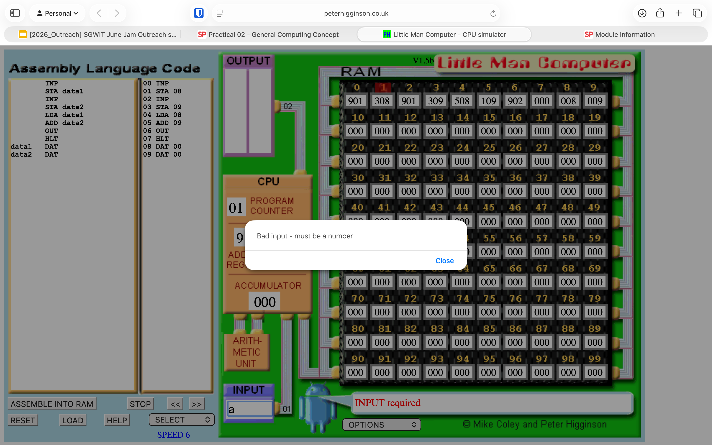

Question: What is the maximum integer that you can input for LMC simulator
999

Question: Using the assembly code from Exercise 2.3, enter 999 as the first input and 888 as the second input. Observe the result displayed in the output area and explain your observations. (You may use AI tools to assist you in finding the answers.)
In the LMC simulator, when 999 is added to 888, the expected result is 1887. However, the LMC can only store 3-digit values (000-999) in each memory location and in the accumulator. Because of this limitation, the results exceeds the maximum value and causes an overflow.

The LMC handles numbers using a limited range (typically -500 +499 in signed representation). When the result 1887 is produced, the simulator effectively wraps the value within its range. This is done by subtracting 1000 repeatedly until the value falls within the valid range:

1887 – 1000 = 887 and 887 is still above the positive limit, so it wraps again into the negative range, resulting in -112

This behaviour shows how overflow occurs in simple computer systems, where values exceeding the storage limit are wrapped around, leading to unexpected negative results instead of the correct mathematical answer.

----- End of Practical -----

