Practical 03 – Boot Sequence

Learning Outcomes
In this practical, learners will explore the computer boot process by accessing BIOS/UEFI settings and understanding how a system initializes during startup. Through hands-on interaction with system firmware and settings, learners will gain insight into how hardware components are checked and configured before the operating system loads. This activity also introduces key concepts such as boot order, security features, and hardware diagnostics. By the end of the practical, learners will be able to:
- Identify the role of BIOS and UEFI in the boot process.
- Understand how the Power-On Self-Test (POST) checks hardware during startup.
- Recognise different boot options such as hard drive, USB, and network boot.
- Explain the purpose of boot order and how it affects system startup.
- Explore basic BIOS/UEFI settings and their functions.

Software and Tools Used in Practical
No. | Tools | Description
1. | Settings | Used to get into the recovery page.
2. | BIOS/UEFI | Firmware used to initialize and configure system settings.
3. | Any AI Tools such as ChatGPT, Gemini, Co-Pilot etc. | To assist or support the learners to find suitable information pertaining to the practical.

BIOS/UEFI
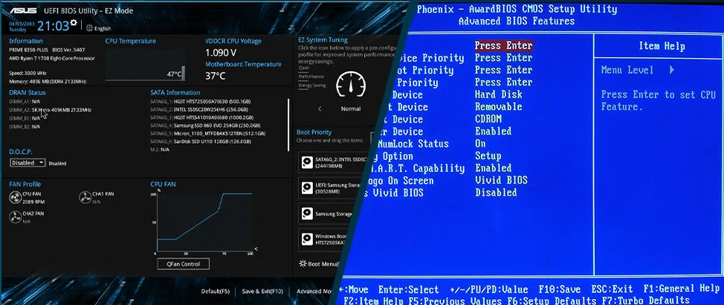
The Basic Input/Output System (BIOS) / Unified Extensible Firmware Interface (UEFI) are essential firmware components that initialise a computer’s hardware during startup and prepare the system for the loading of the operating system. BIOS is the traditional firmware found in older systems, responsible for performing basic hardware checks and managing the boot process. UEFI is the modern replacement for BIOS, offering improved performance, enhanced security features, and a more user-friendly interface. Both serve as a critical bridge between the computer’s hardware and its operating system.
At the core of both BIOS and UEFI is the responsibility to perform the Power-On Self-Test (POST), which checks whether key hardware components such as the CPU, memory, and storage devices are functioning correctly. They also manage important system configurations, including boot order, hardware settings, and low-level system controls. UEFI extends these capabilities by supporting faster boot times, larger storage devices, graphical interfaces, and advanced features such as Secure Boot, which helps protect the system from malware attacks during startup.
In modern computing environments, BIOS and UEFI, particularly UEFI, play a crucial role in ensuring system stability, security, and flexibility. As the demand for secure and efficient systems increases, features such as Secure Boot and Trusted Platform Module (TPM) integration help protect sensitive data and prevent unauthorised access. Additionally, UEFI supports virtualization technologies and modern hardware advancements, making it essential for running today’s operating systems and applications. Overall, understanding BIOS and UEFI provides a strong foundation for effectively managing, maintaining, and troubleshooting computer systems.

Practical Exercise

Exercise 3.1 Access BIOS/UEFI from your Personal Computer
- Access the BIOS/UEFI by pressing the required key or key combination on your keyboard. See the table below based on your laptop model.
(Note: You need to repeatedly press the key immediately after powering on your computer, else the system will quickly proceed to boot into Windows 11.)

Commonly used BIOS/UEFI Keys

Manufacturer | Boot Menu | BIOS/UEFI Key
Acer | Esc, F12, F9 | Del, F2
Asus | F8, Esc | F9, Delete, F2
Dell | F12 | F2
Fujitsu | F12 | F2
HP | Esc, F9 | Esc, F10, F1
Intel | F10
Lenovo | F12, F8, F10, Fn + F11 | F1, F2, Novo button
NEC | F5 | F2
Packard Bell | F8 | F1, Del
Samsung | F12, F2, Esc | F2, F10
Sony | Assist button, F11, Esc, F10 | Assist button, F1, F2, F3
Toshiba | F12

- Alternately you may boot it from Windows Operating System. You can do it by navigating to settings. Press the Windows button on your keyboard and looking for settings.
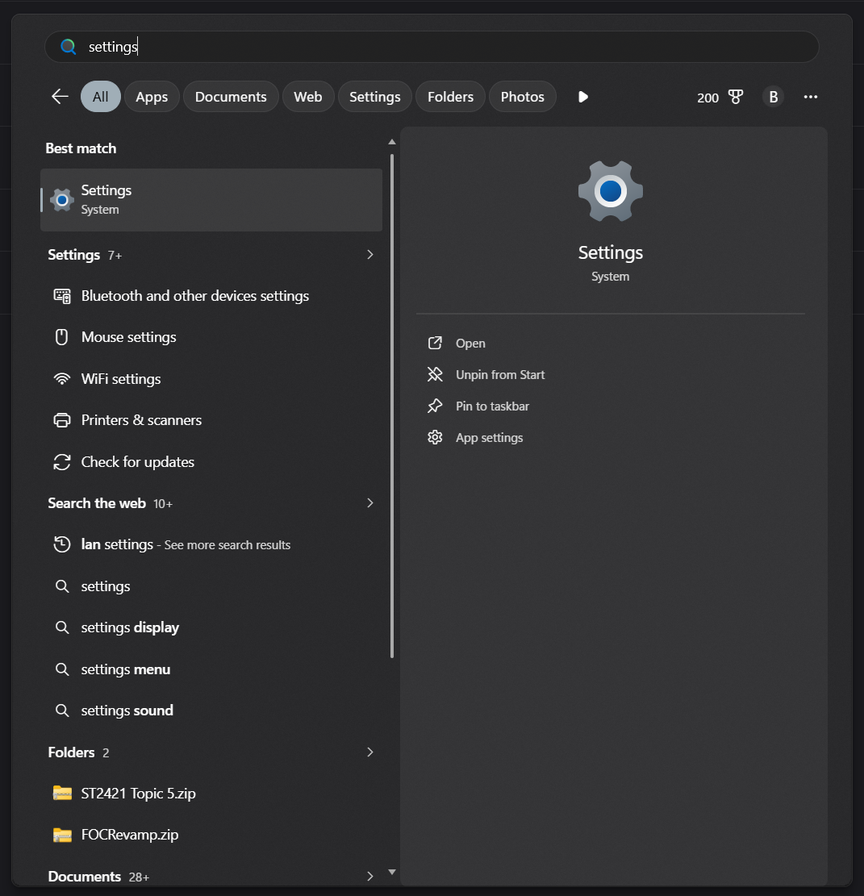

- Click on System and click on Recovery.
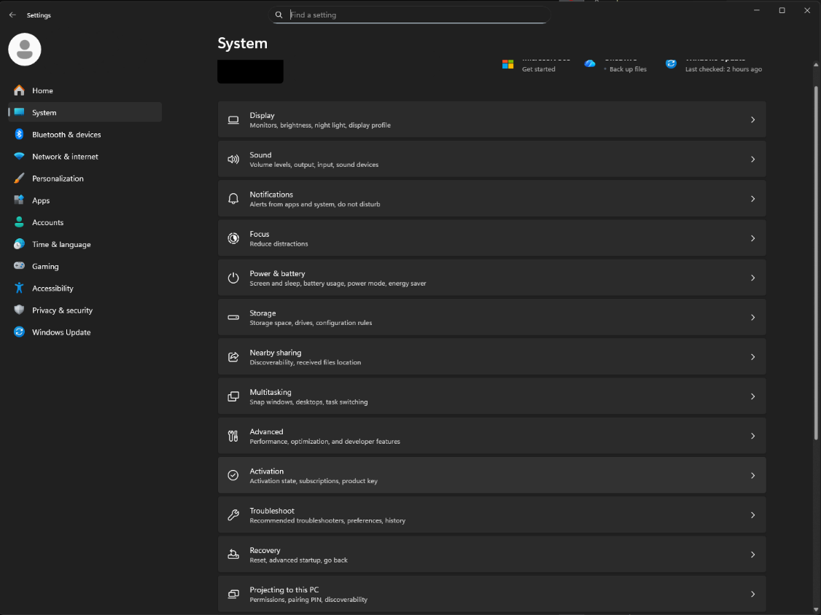

- Search for the button Restart now at Advanced startup under Recovery options. (Note: you might not be able to access this practical lab exercise. It is recommend that you in groups and one of the group members perform the activities in this practical lab)
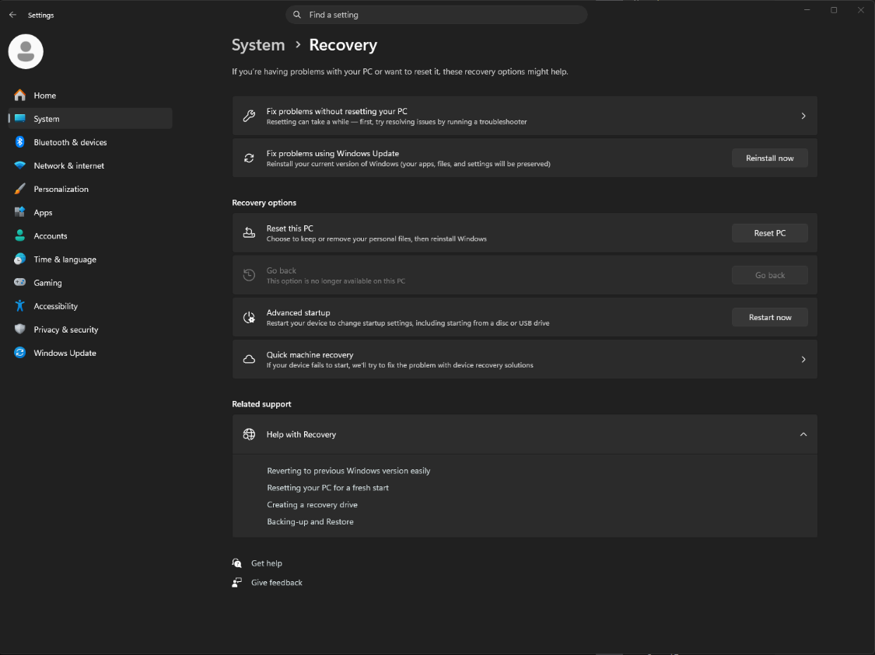

- Wait for the computer to reboot and a Troubleshoot screen will appear, select Advanced options
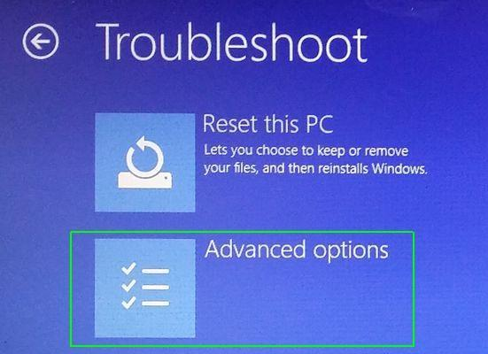

- Then select UEFI Firmware Settings. (Note: If you are unable to see the options, move to select “Startup Settings” instead and initiate a computer restart, repeat step 1 of this practical exercise.)
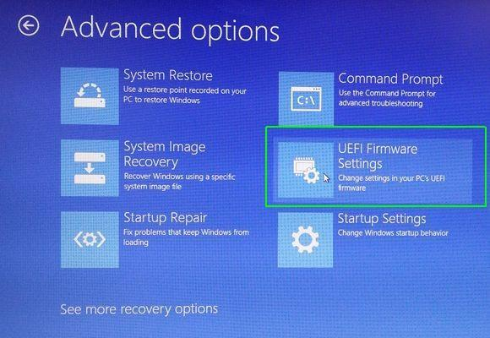

- Select “Restart”.
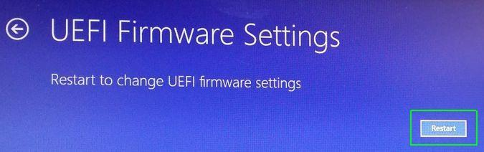

- Your system will now restart and boot into the BIOS settings.
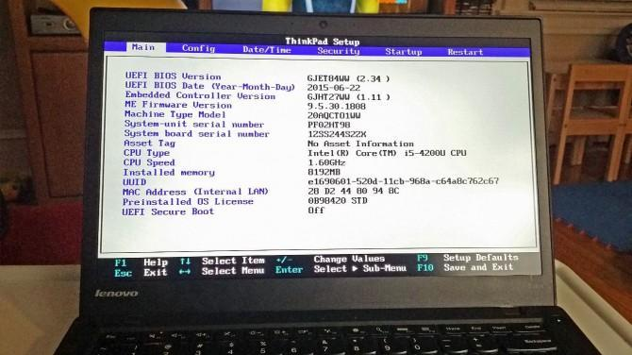

Exercise 3.2 Reflection Questions
Question: What boot options are available on your PC, and can the boot order be modified? (You may use AI tools to assist you in finding the answers.)
Common boot options for a PC include the main disk, flash drives for windows reinstallation, optical disks, and network booting, however this is not common as it requires a server and ethernet.

Yes the boot order can be changed through the BIOS settings to allow booting from something else that is not the default.

Question: What are some configuration features available in the BIOS/UEFI settings? (You may use AI tools to assist you in finding the answers.)
- Switching from UEFI to legacy mode to allow booting legacy systems
- Changing the GPU used if an external GPU is detected, e.g. from external to internal
- Setting boot password
- Changing boot order
- Configuring secure boot, to trust different files and allow other systems to boot

Question: What is the function of CMOS battery.
(You may use AI tools to assist you in finding the answers.)
The CMOS battery is a small battery located on the computer’s motherboard. Its main function is to provide power to the CMOS chip when the computer is turned off.

Question: Are CMOS batteries present in both BIOS-based and UEFI-based motherboards? (You may use AI tools to assist you in finding the answers.)
Yes it is present in both

Question: What is the definition of Power-On Self-Test (POST) and list the sequence of the test. (You may use AI tools to assist you in finding the answers.)
Power-On Self-Test (POST) is an automatic diagnostic process carried out by a computer’s firmware (BIOS or UEFI) immediately after the system is powered on. Its purpose is to check that the hardware components of the system are functioning properly before the operating system loads.

• Power Supply Initialization
- When the computer is turned on, the power supply provides stable electricity to all components.
• CPU Initialization
- The processor (CPU) starts executing instructions stored in the BIOS/UEFI firmware.
• BIOS/UEFI Activation
- BIOS/UEFI firmware takes control and begins the POST process.
• System Timer Check
- The system timer is verified to ensure proper system timing.
• Memory (RAM) Check
- The system tests and initializes RAM.
- If RAM errors occur, the system may emit beep codes or display warnings.
• Video System Initialization
- The graphics card (or integrated graphics) is tested and initialized.
- Enables display output so messages can be shown.
• Keyboard and Input Devices Check
- Basic input devices like the keyboard are tested.
• Storage Devices Detection
- Hard drives, SSDs, and other storage devices are identified and checked.
• Hardware Components Verification
- Additional components such as expansion cards, ports, and controllers are tested.
• Boot Device Identification
- BIOS/UEFI searches for a bootable device (e.g., hard drive, USB, CD/DVD).
• Transfer to Bootloader
- Once hardware checks pass, control is passed to the bootloader, which loads the operating system.

Question: Beside testing for keyboard issues, what other component does POST check for? (You may use AI tools to assist you in finding the answers.)
Depending on the BIOS settings, POST can be selected either fast boot or normal boot.

A normal boot will reset all hardware state, verifying every single component like USB, RAM, storage, network, etc

Fast boot will only check the boot drive, and initialise the video drivers but replaces it with a simple logo rather than boot logs that is present in normal boot. it may fail to recognise new hardware as it doesn’t scan for everything

----- End of Practical -----

