Practical 04 – Digital Representation

Learning Outcomes
In this practical, learners will explore how data is represented digitally through number systems, colour models, and file structures by using tools such as colour pickers and hex editors. Through hands-on activities, learners will examine how information is encoded in binary, hexadecimal, and RGB formats, and how file signatures identify different file types. This practical helps learners build a foundational understanding of how computers store and interpret data at a low level. By the end of the practical, learners will be able to:
- Identify how colours are represented using RGB values in decimal and hexadecimal formats.
- Understand the relationship between binary, hexadecimal, and character representations.
- Use a hex editor to view and analyse file contents.
- Recognise file signatures and explain how they identify file types.
- Apply basic knowledge of number systems to interpret digital data.

Software and Tools Used in Practical
No. | Tools | Description
1. | Web browser (Microsoft Edge / Google Chrome) and stable internet connection. | Accessing W3schools colour picker website and online HEX Editor.
2. | Any AI Tools such as ChatGPT, Gemini, Co-Pilot etc. | To assist or support the learners to find suitable information pertaining to the practical.

Additional Resources
https://learningcontent.cisco.com/games/binary/index.html
https://www.cuemath.com/numbers/decimal-to-hexadecimal/

Practical Exercise

Exercise 4.1 Representing colour in RGB
- Browse to the following website https://www.w3schools.com/colors/colors_picker.asp.
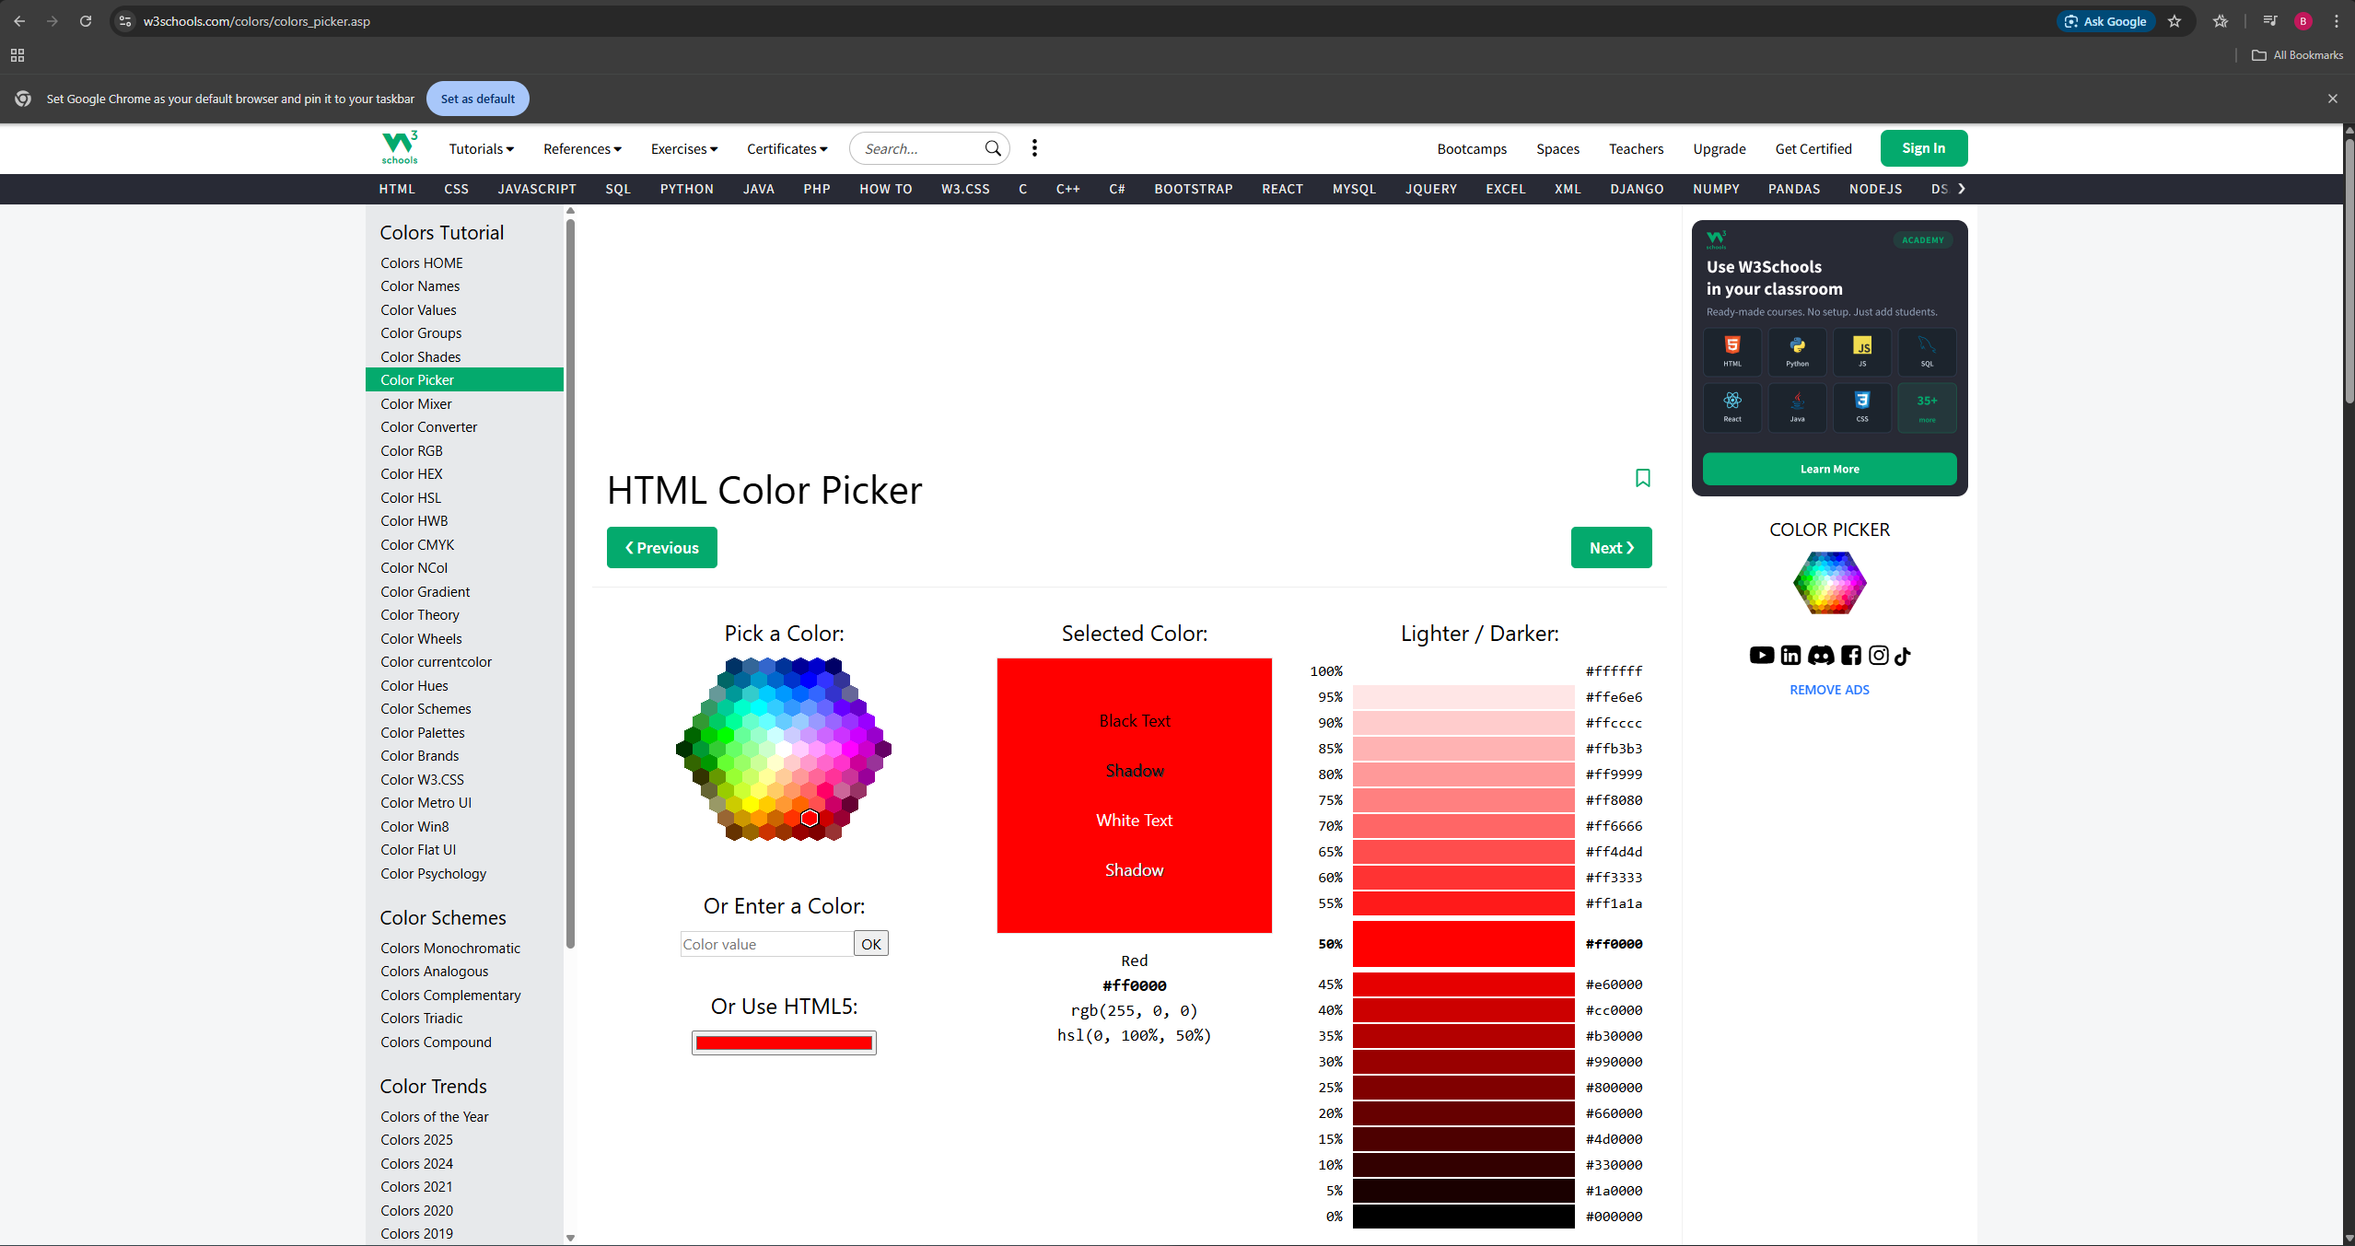

- As colours are represented in decimal or hexadecimal, each colour has a unique decimal and Hexadecimal representation. You can use decimal and hexadecimal to derive any colour.
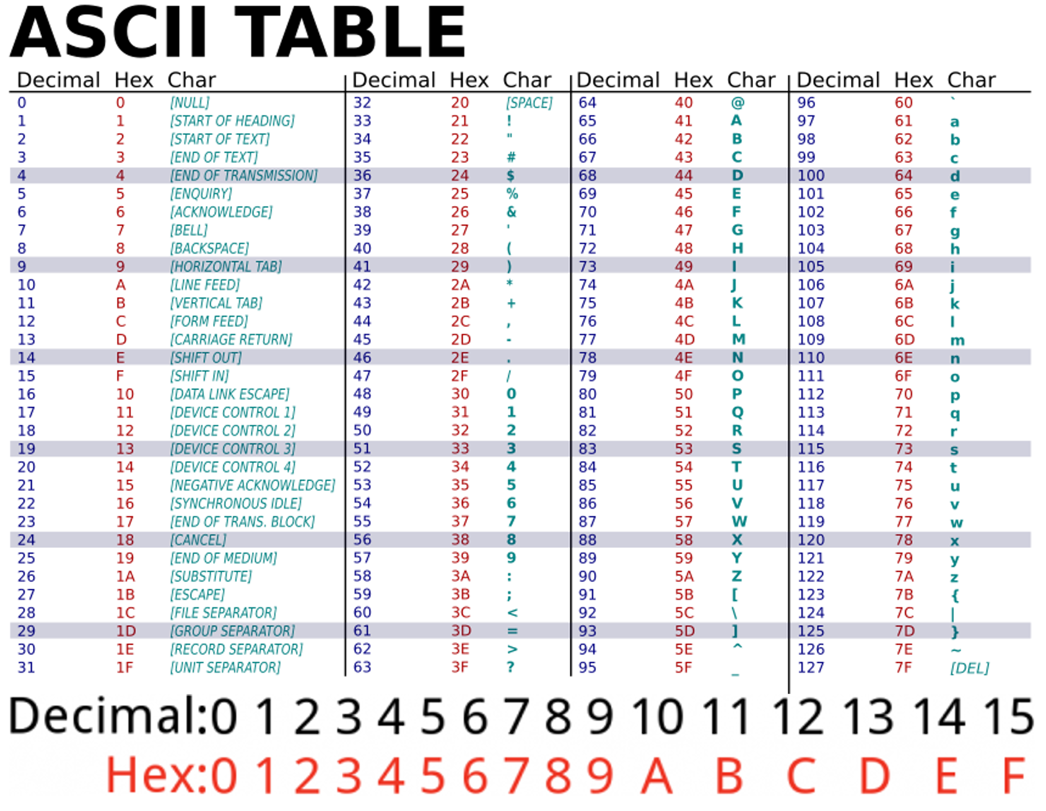

Question: Browse to the website in step 1 and check for the decimal, and hexadecimal of the following colours.
Colour | RGB in Decimal | RGB in Hexadecimal
Black | 0, 0, 0 | #000000
White | 255, 255, 255 | #ffffff
Your Favourite Colour | 255, 51, 204 | #ff33cc

Exercise 4.2 Access the File Header
- Using notepad, create a text file and name it file1.txt. Type I love programming into file1.txt.
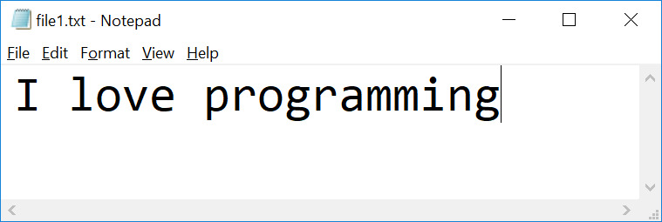

- Check the file properties by right clicking on the file and clicking Properties. The file is listed as a text document.
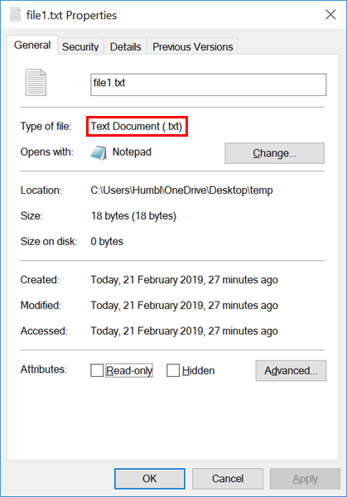

Question: Can you view the text file as an image? (You may use AI tools to assist you in finding the answers.)
You may be able to open the text file as an image by changing the files header into one that an image uses, allowing for the system to recognise it as a image. However when you open it the image viewer may report that the image is corrupted

- Download and install HxD Hex Editor (https://mh-nexus.de/downloads/HxDSetup.zip).
- Open fil1.txt using HxD and observe the hex code of file1.txt
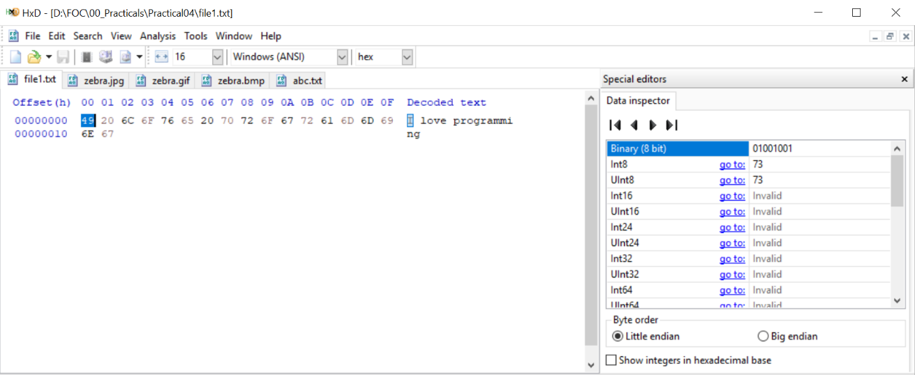

- Use the following link (https://www.ascii-code.com/) to interpret the following the hexadecimal on step 6.

Question: Using the link provided in step 7 (https://www.ascii-code.com/), interpret the following ASCII characters
ASCII Character | Hexadecimal | Binary (8 bit)
I | 49 | 01001001
[space] | 20 | 00100000
L | 4C | 01001100
o | 6F | 01101111
v | 76 | 01110110
e | 65 | 01100101
[space] | 20 | 00100000
S | 53 | 01010011
P | 50 | 01010000

- Download image from the following link below:
- https://upload.wikimedia.org/wikipedia/commons/thumb/f/f1/Heart_coraz%C3%B3n.svg/250px-Heart_coraz%C3%B3n.svg.png (save it as heart.png)
- https://encrypted-tbn0.gstatic.com/images?q=tbn:ANd9GcRBpPfs3F4bMM9DPTEpE89frypGOUAPPVwAzg&s (save it as heart.jpg)
- https://lh6.googleusercontent.com/proxy/2Cqd2M_deCWww60t9pkxahVH67VuguaFWudGXHXj40CxV37y3xYXDymQ-0SLAm_RfBs5KIjAFakNfK3ee_XqulP6U29kNHEz82CgCfb5W9LodRN5XiTw4rgoVJkiz1LHjLhJTyFk (save it as heart.gif)

- Open these images in HxD and observe the Hexadecimal code.
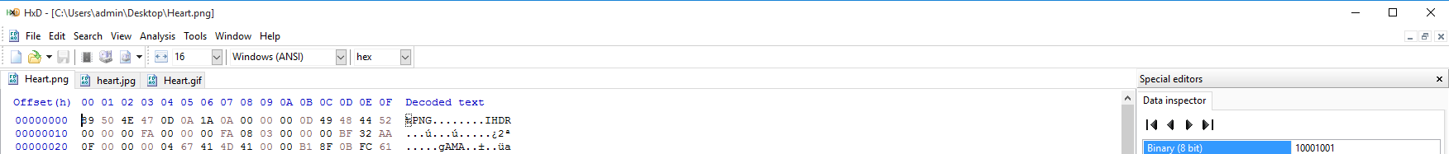

Question: What are the first 6 bytes decoded for each of these images?
heart.png
Offset | 00 | 01 | 02 | 03 | 04 | 05
Byte | 89 | 50 | 4E | 47 | 0D | 0A
Character | % | P | N | G | . | .

heart.jpg
Offset | 00 | 01 | 02 | 03 | 04 | 05
Byte | FF | D8 | FF | E0 | 00 | 10
Character | 4A | 46 | 49 | 46 | 00 | 01

heart.gif
Offset | 00 | 01 | 02 | 03 | 04 | 05
Byte | 47 | 49 | 46 | 38 | 39 | 61
Character | 90 | 01 | 90 | 01 | F6 | 00

- You can visit the following link (https://en.wikipedia.org/wiki/List_of_file_signatures) to find out more about file signatures.

Exercise 4.3 Decode Unidentified Files (Optional)
Question: Download the following file (https://drive.google.com/file/d/1vf0SBkI1LdWQvYmK9yM5AyJ0fHKE6DHR/view). Identify the file format.

Hint:
- Open the file using HxD
- Visit web site https://en.wikipedia.org/wiki/List_of_file_signatures to find out the meaning of above hex code
- Rename the extension of the file

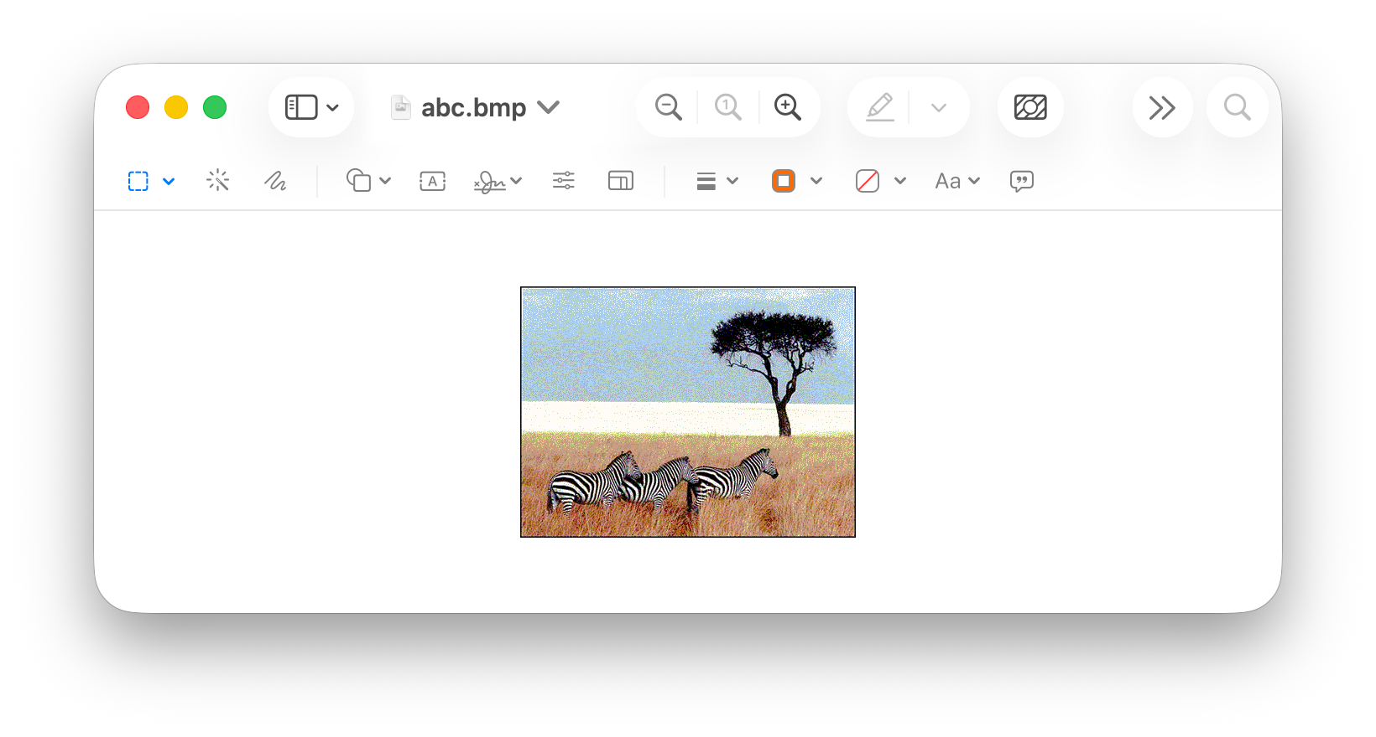

----- End of Practical -----

