Practical 05 – IP and Ping Utility

Learning Outcomes
In this practical, learners will explore basic networking concepts by configuring IP settings, testing connectivity using the ping utility, and analysing network traffic with tools such as Command Prompt and Wireshark. Through hands-on activities, learners will understand how devices communicate within a network and across the internet, as well as how data packets are transmitted and received. This practical will build foundational skills in network configuration, troubleshooting, and traffic analysis. By the end of the practical, learners will be able to:
- Identify key network information such as IP address, subnet mask, default gateway, and MAC address.
- Understand the difference between private and public IP addresses.
- Configure and verify static and dynamic (DHCP) IP settings.
- Use the ping utility to test network connectivity at different levels (localhost, local network, and internet).
- Analyse basic network traffic using Wireshark and interpret ICMP packets.

Software and Tools Used in Practical
No. | Tools | Description
1. | Web browser (Microsoft Edge / Google Chrome) and stable internet connection. | To find public IP address
2. | Command Prompt (ipconfig.exe) | Utility used for retrieving network information like NIC model, IP and MAC address.
3. | Control Panel (control.exe) | Changing the IP addresses, Subnet Mask, Default Gateway and DNS Servers.
4. | Command Prompt (nslookup.exe) | Querying DNS server to obtain IP addresses and domain names.
5. | Any AI Tools such as ChatGPT, Gemini, Co-Pilot etc. | To assist or support the learners to find suitable information pertaining to the practical.

Additional Resources
https://www.youtube.com/watch?v=oHQvWa6J8dU

Practical Exercise

Exercise 5.1 Finding Private IP address
- Run Command Prompt from your Windows Operating System.
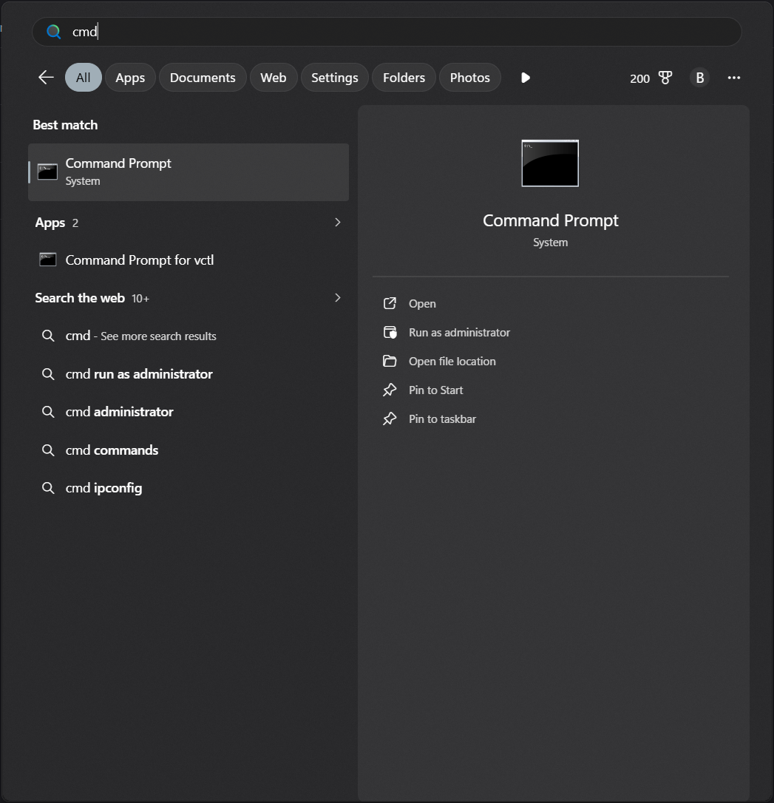
- In the command prompt type in the following command to list all network interface information:
ipconfig /all
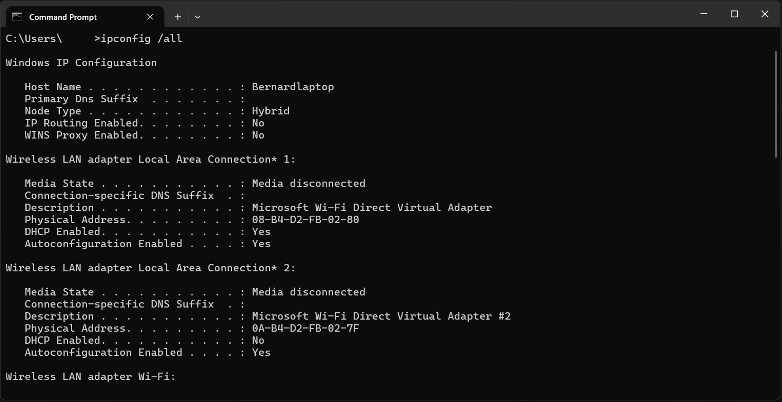
- Locate your network interface information (Note: Since your laptop connects to the school network via WiFi, the network interface information will be listed under “Wireless LAN adapter Wi-Fi”.).
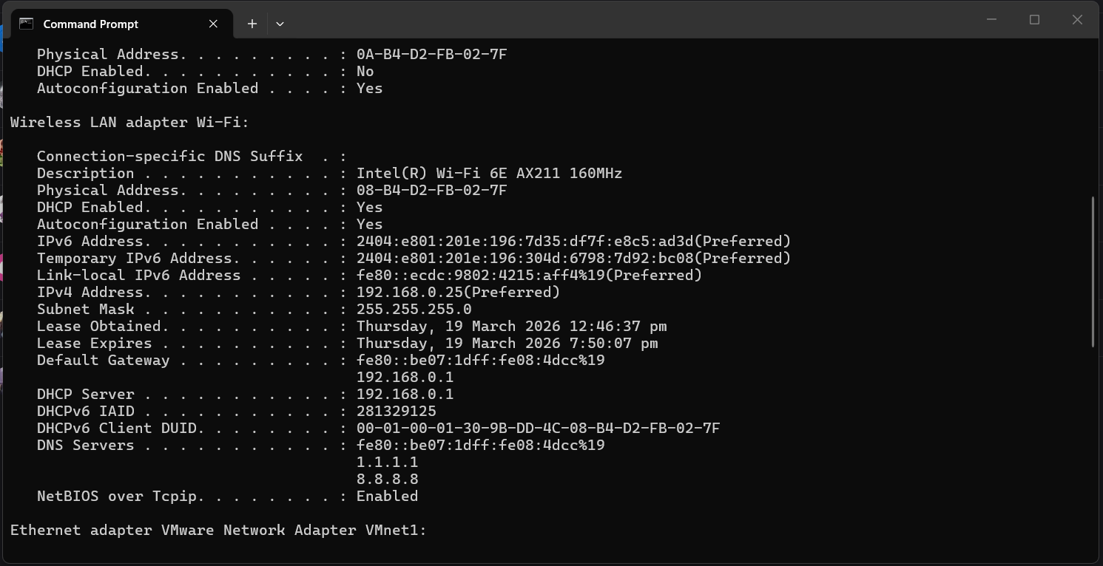

Question: Using the ipconfig /all command on your computer, record the following network information from the Command Prompt output. (Note: The values will differ for each computer, as MAC addresses are unique and IP addresses vary based on the connected network.)
Physical Address (MAC) | 6a:11:f5:e2:85:92
IP Address | 172.20.10.3
Subnet Mask | 255.255.255.240
Default Gateway | 172.20.10.1
DNS Server | 172.20.10.1
DHCP Enabled | Yes

Exercise 5.2 Configuring Static IP Address for Computer
- Use Win + R to start “Run”, type in Control Panel and click Ok.
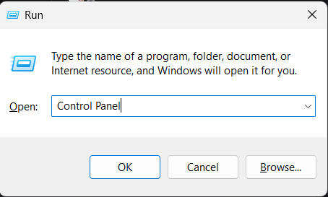

- Select Network and Internet and select Network and Sharing Center.
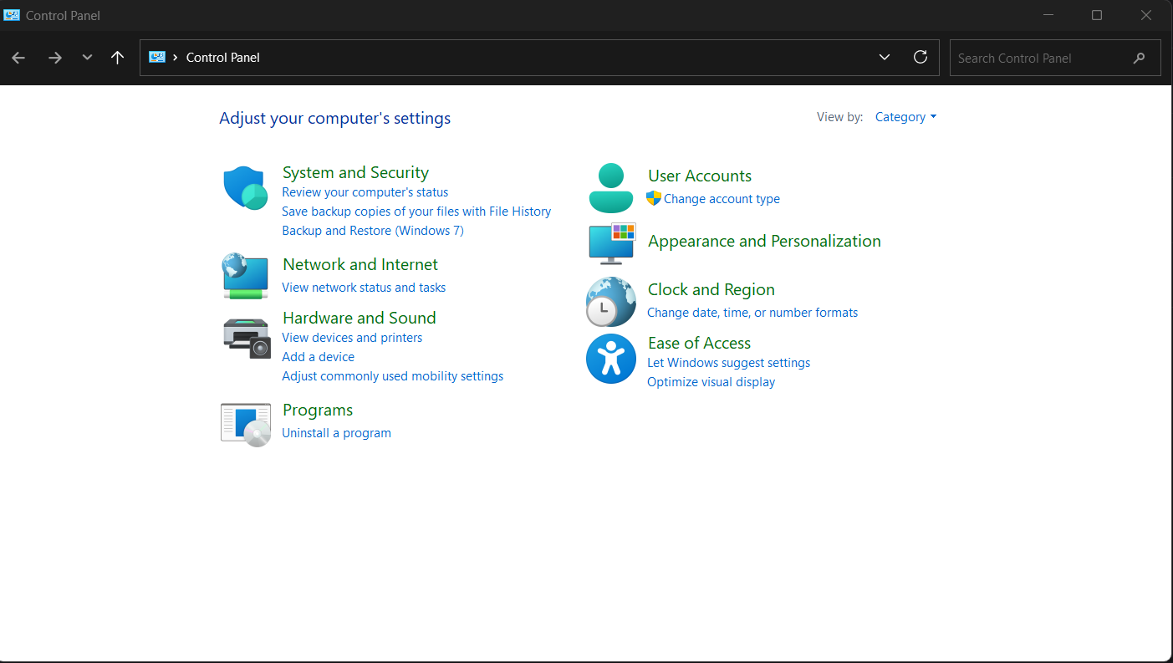
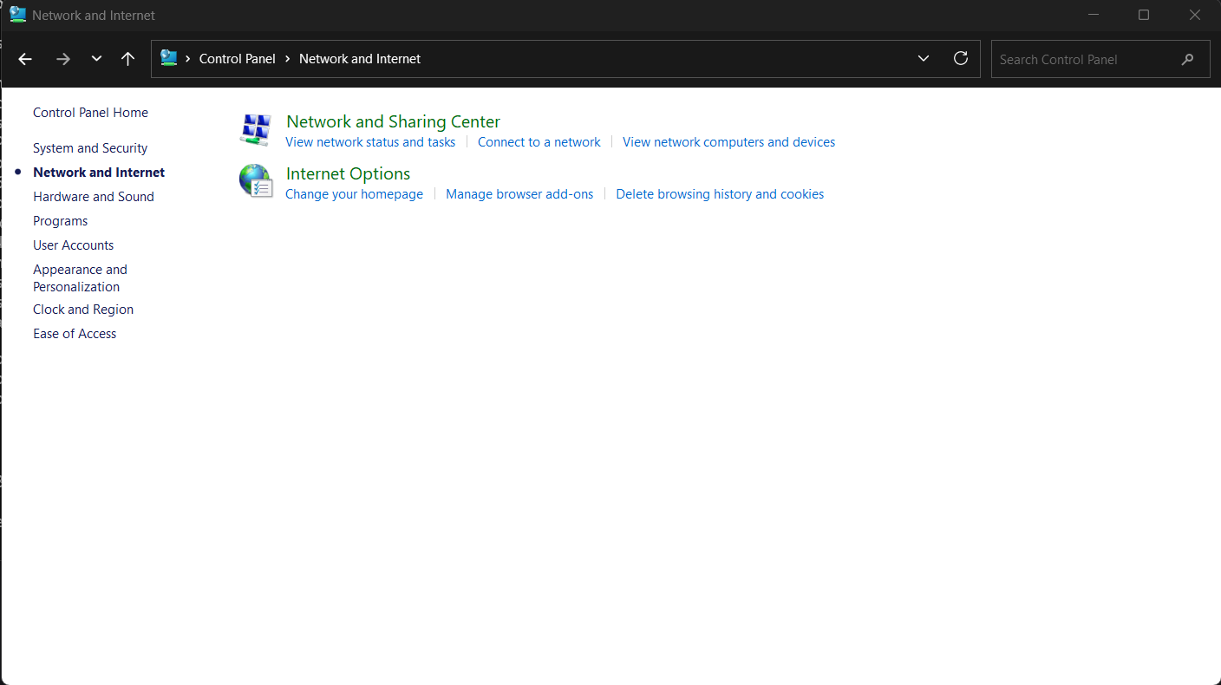

- Click on the connection and select Properties. (Note: Connection values will differ depending on the Wi-Fi network that you join.)
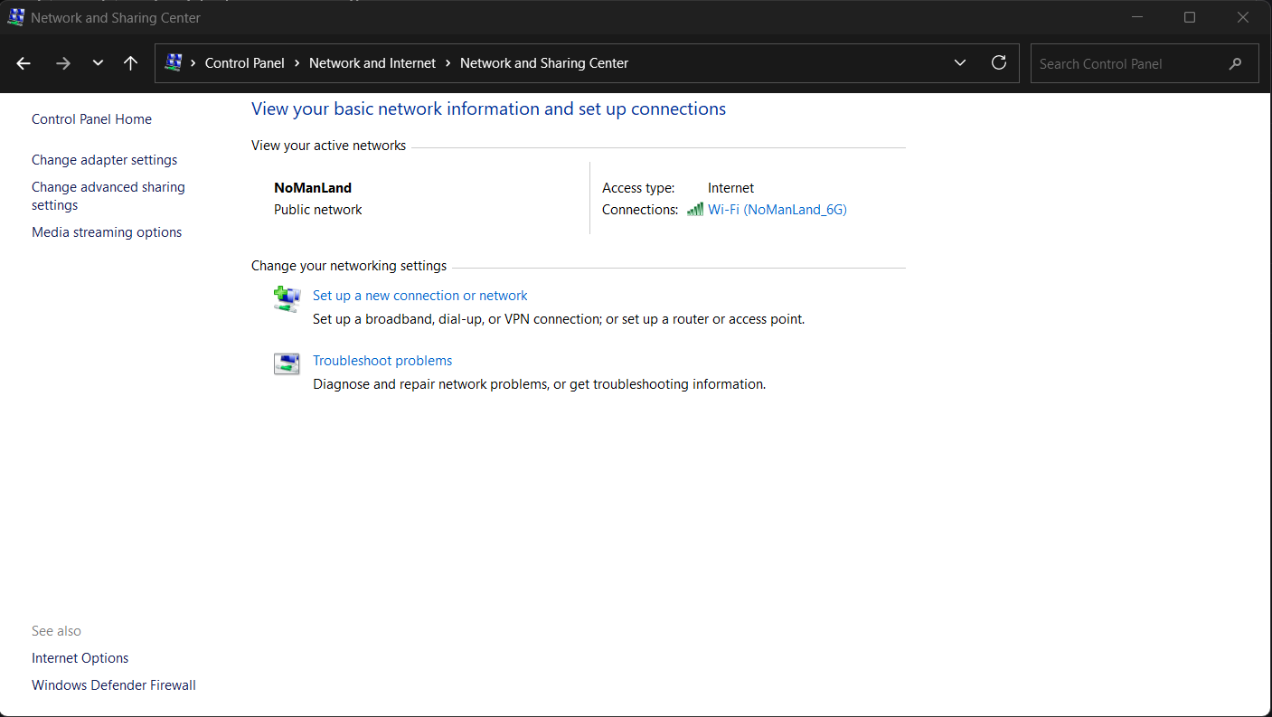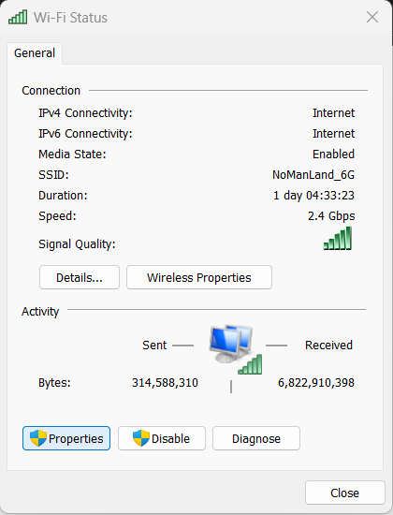

- Double-click on Internet Protocol Version 4 (TCP/IPv4). Select Use the following IP address radio button and set your preferred IP address.
(Note: Ensure the static IP address is configured carefully, as even a small error in the IP address may cause the computer to lose network connectivity. If you are uncertain with the IP address, please consult your lecturer.)

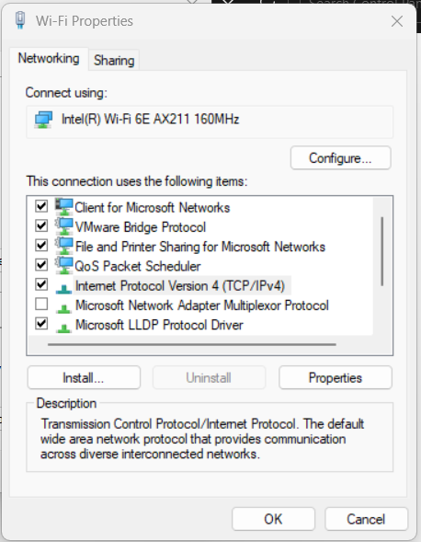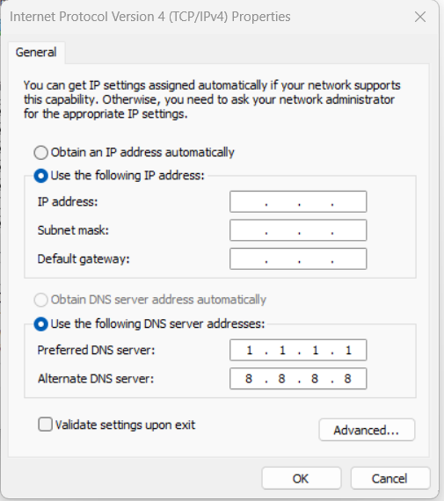

- Upon setting your static IP address, repeat step 1 to step 3 of Exercise 5.1 and observe the change in your IP address.

- To check whether the static IP address you configured allows you to connect to the internet, you can type in the following command in Command Prompt.
ping 8.8.8.8

Note: if you are connected to the internet, you should see something like this:
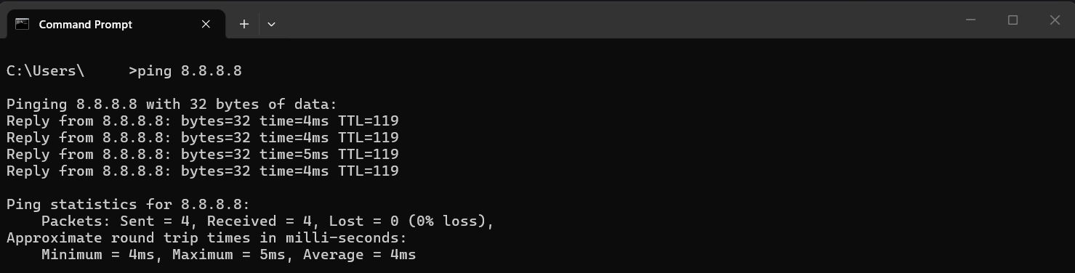
If you are not connected to the internet, please consult your lecturer to assist you in troubleshooting the static IP address. Do note that there might be some issue in setting static IP address in SP campus as the campus networks may not allow the configuration of static IP address.

- Repeat Step 4 to Step 7 of Exercise 5.2 to restore your configuration to DHCP by selecting the Obtain an IP address automatically radio button. Then set your DNS server address by selecting Use the following DNS server addresses: radio button. The key in the following:
Preferred DNS Server: | 1.1.1.1 | Uses Cloudflare (1.1.1.1) as the primary DNS Server.
Alternate DNS Server: | 8.8.8.8 | Uses Google (8.8.8.8) as the alternate DNS Server in the event Preferred DNS Server is offline.

- To check whether you have configured the DNS server correctly you can go to Command Prompt (Step 1 of Exercise 5.1) and key in the following command to find the IP address of www.google.com.
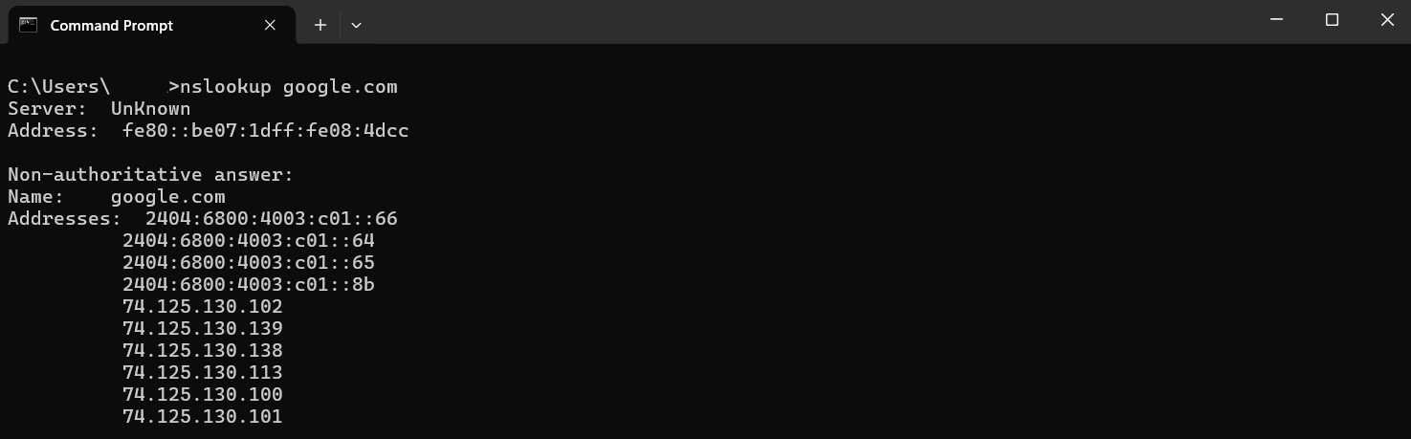

Exercise 5.3 Understand the difference between Private and Public IP address.
- Browse to the link in the picture below and check what your public IP address is.
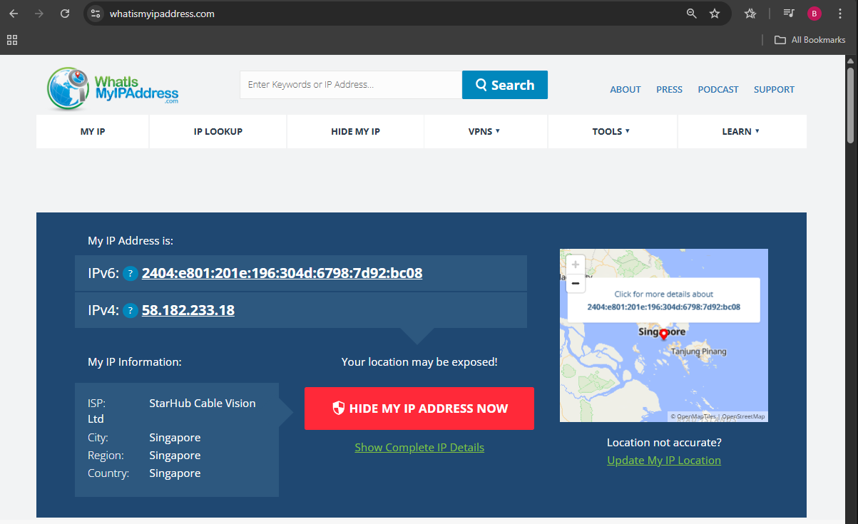

- Repeat step 1 to step 3 of Exercise 5.1 to find your private IP address.
Question: Observe and note down your Public and Private IP address
Public IP Address: | 172.226.214.35
Private IP Address: | 172.20.10.3

Question: Using AI Tools, find out what the difference between public and private IP addresses is, and whether public IP addresses in Singapore changes.
Public IP addresses are assigned by your ISP and are visible on the internet, allowing your network to communicate globally, while private IP addresses are assigned by your router and used only within your local network for communication between devices. In Singapore, most home users have dynamic public IPs, meaning they can change occasionally (e.g., after restarting your router or over time), unless you pay for a static IP, which remains fixed.

Exercise 5.4 Different Ping Methods
- To troubleshoot whether TCP/IP is working properly on the local host, you can ping the loopback address by entering the following command on the Command Prompt:
ping 127.0.0.1
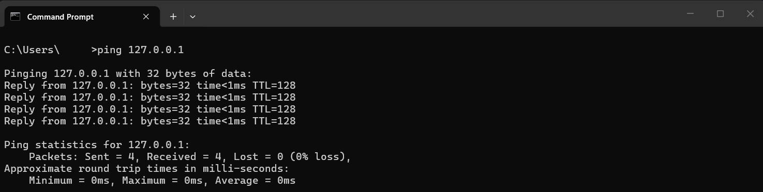
Question: Observe and note down the “Approximate round trip times in milli-seconds:”
Minimum | Maximum | Average
0.570 | 1.420 | 0.641

- You can also troubleshoot name cache resolution by using the following command:
ping localhost
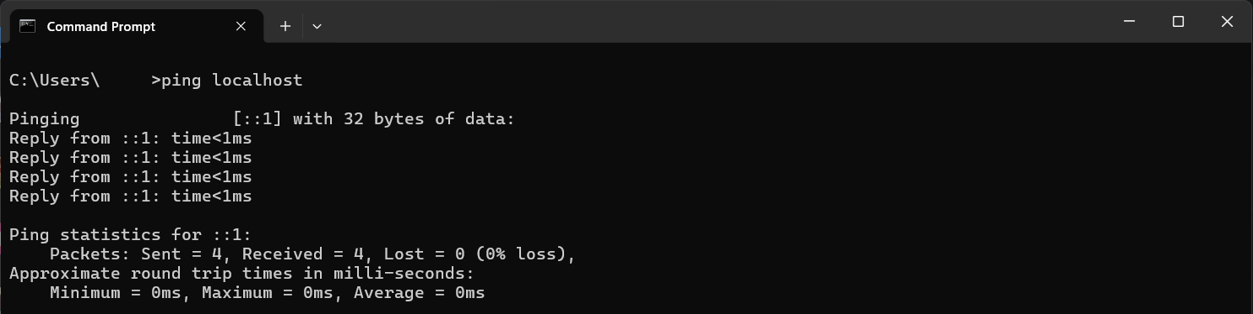
Note: The value in the red box should be your computer’s name. You can also use the command hostname in Command Prompt to check your hostname. Now verify that both commands give you the same hostname.

- You can also troubleshoot network connectivity by pinging IP addresses (your own IP or other computers’ IP address). Repeat step 1 to step 3 of Exercise 5.1 to find your IP address. Then type in the following command in the Command Prompt.
ping <IPv4 Address>
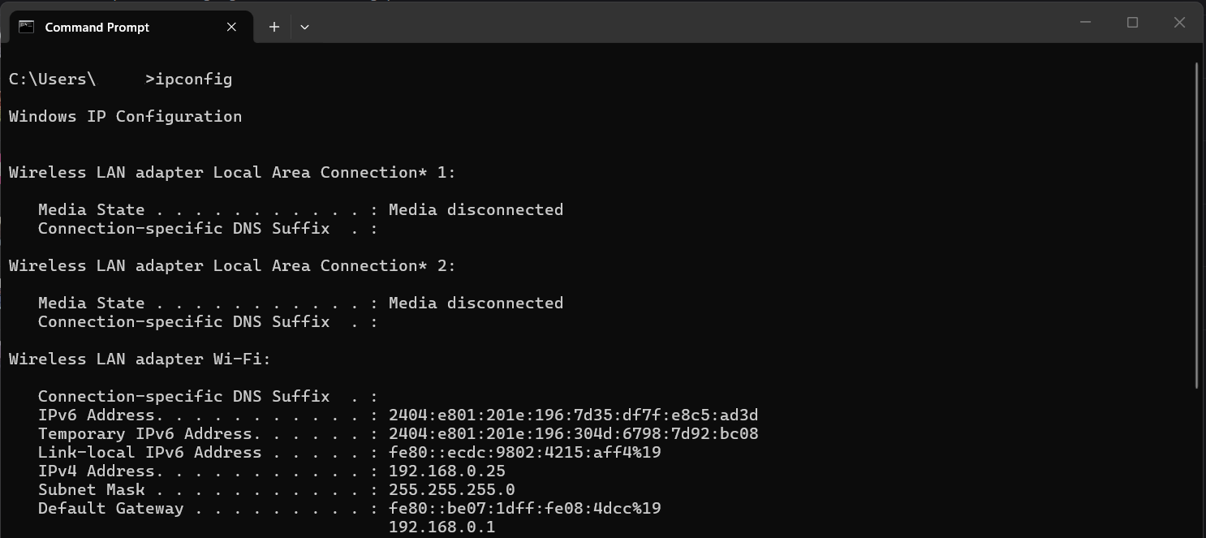
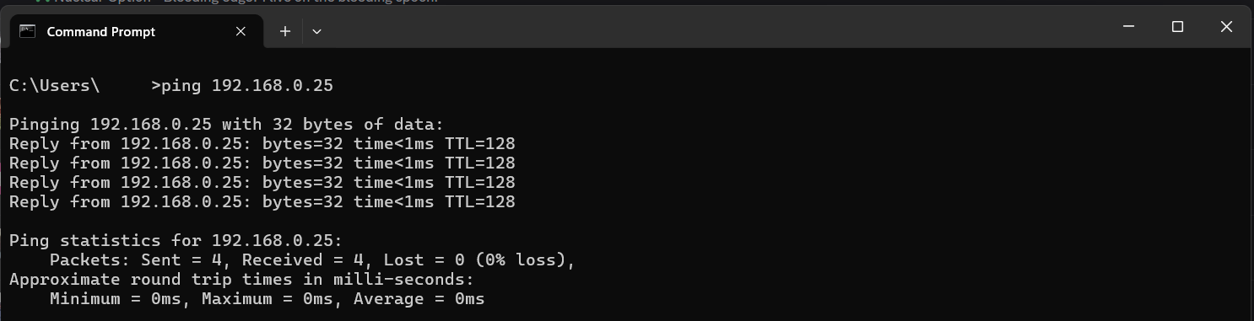
Note: <IPv4 Address> is the IPv4 address of your computer, which you obtain by repeating step 1 to step 3 of exercise 5.1. For example, if the IP address of the computer is 192.168.0.25, the command should be:
ping 192.168.0.25.
- You can also troubleshoot network connectivity by pinging the hostname of the computer. You can use the following command in Command Prompt to check for you host name.
hostname
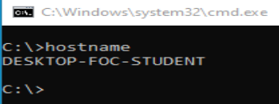

- You can then ping the hostname of your computer by typing the following command in Command Prompt.
ping <hostname>

Note: <hostname> is the hostname of the computer which you had obtained in the previous step (Step 17). In the example above, the hostname is DESKTOP-FOC-STUDENT, therefore the command should be
ping DESKTOP-FOC-STUDENT.

- To troubleshoot whether the computer can connect to the router, you can ping the Default Gateway. To ping the Default Gateway, you must obtain the IP address of the Default Gateway (Repeat Step 16).
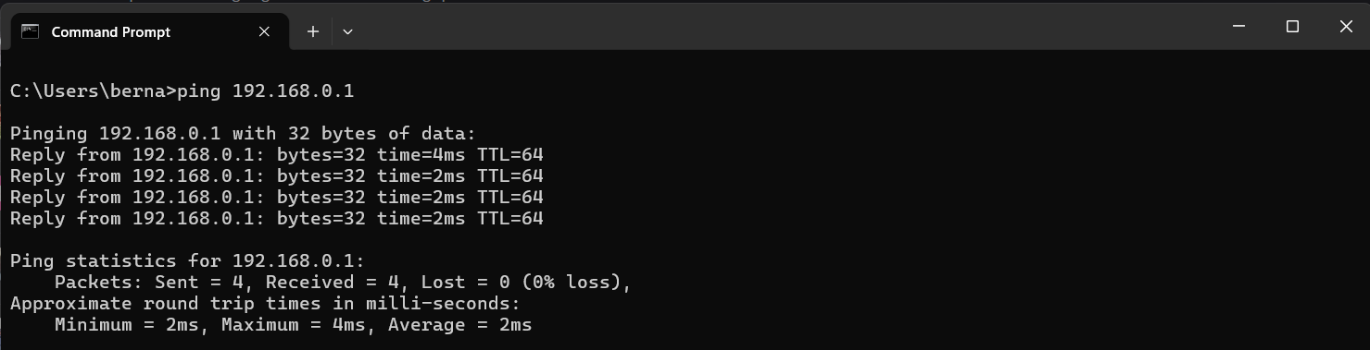
Note: In the example, the IP address of the Default Gateway is 192.168.0.1, therefore the command to ping the Default Gateway will be ping 192.168.0.1.

- To troubleshoot internet access of the network, you can ping the public DNS Servers such as Google or Cloudflare DNS Server, as these DNS Servers are located on the Internet. To test internet connectivity, you can enter the following command:
ping 1.1.1.1 or ping 8.8.8.8.
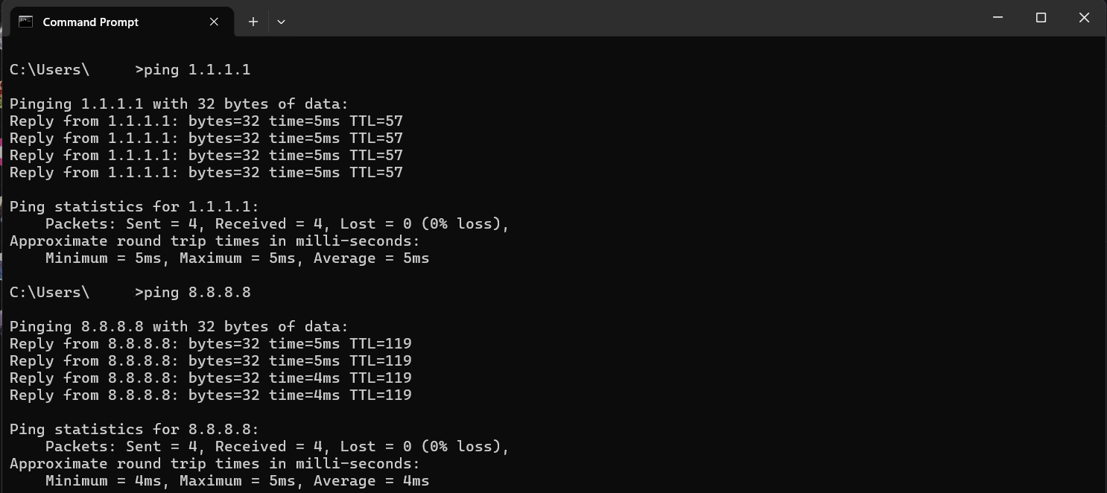

- Alternatively, you can also ping the IPv6 address of the public DNS Servers. 2001:4860:4860::8888 is the IPv6 address of one of Google's public DNS servers. To ping you can use the following command:
ping 2001:4860:4860::8888
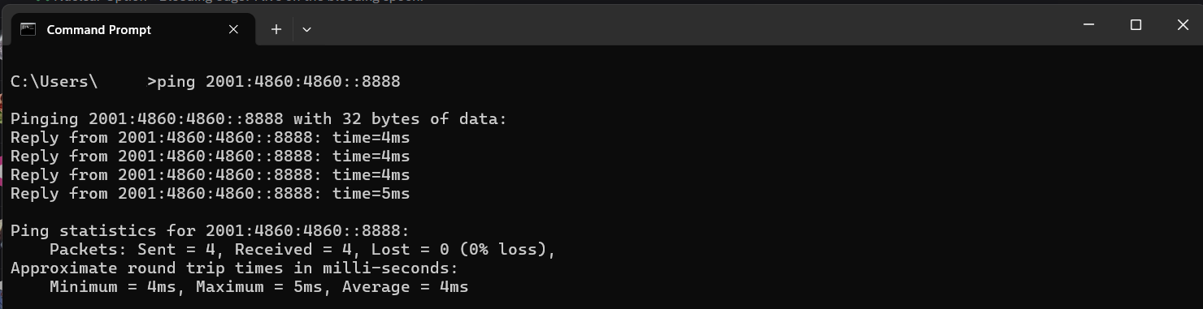

----- End of Practical -----

