Practical 06 – Capture HTTP Traffic and IP Traffic

Learning Outcomes
In this practical, learners will explore how web traffic is transmitted across a network by capturing and examining HTTP, HTTPS, TCP, IP, and Ethernet information using Wireshark. Through hands-on activities, learners will observe how browsers generate web requests, how servers respond, and how protocol details such as port numbers, IP addresses, MAC addresses, and HTTP headers can be identified from captured packets. This practical will build foundational skills in packet capture, protocol analysis, and understanding how web communication takes place across a network. By the end of the practical, learners will be able to:
- Install Wireshark network traffic analyser.
- Capture network traffic generated from web browsing activities using Wireshark.
- Identify and analyse HTTP request and response messages from captured traffic.
- Interpret key HTTP information such as requested resources, response codes, and User-Agent details.
- Examine TCP packets to identify source and destination port numbers involved in web communication.
- Analyse IP packet details such as source and destination IP addresses.
- Identify Ethernet frame information, including source and destination MAC addresses.
- Apply packet analysis skills to observe how web browsers communicate with web servers over a network.

Software and Tools Used in Practical
No. | Tools | Description
1. | Web browser (Microsoft Edge / Google Chrome) and stable internet connection. | Generating example website network traffic.
2. | Windows Operating System (Windows 11) | Operating used for installing Wireshark network traffic analyser
4. | Wireshark | Network protocol analyser used to capture and analyse HTTP and HTTPS traffic.
5. | Any AI Tools such as ChatGPT, Gemini, Co-Pilot etc. | To assist or support the learners to find suitable information pertaining to the practical.

Practical Exercise

Exercise 6.1 Installing Wireshark Traffic Analyser
- In Windows Operating System, open a web browser (Microsoft Edge or Google Chrome) and browse to the following website https://www.wireshark.org/#download
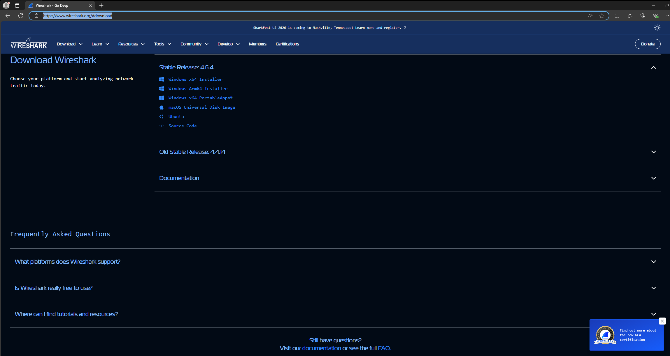
- Click on the Windows x64 Installer to download Wireshark analyser.
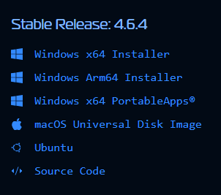
Note: If prompted with the donation page just select No thanks, just download

- Once you had completed the download, install the Wireshark by double clicking the file in your Download folder (Note: By default, downloaded files will be in your download folder unless you specify).
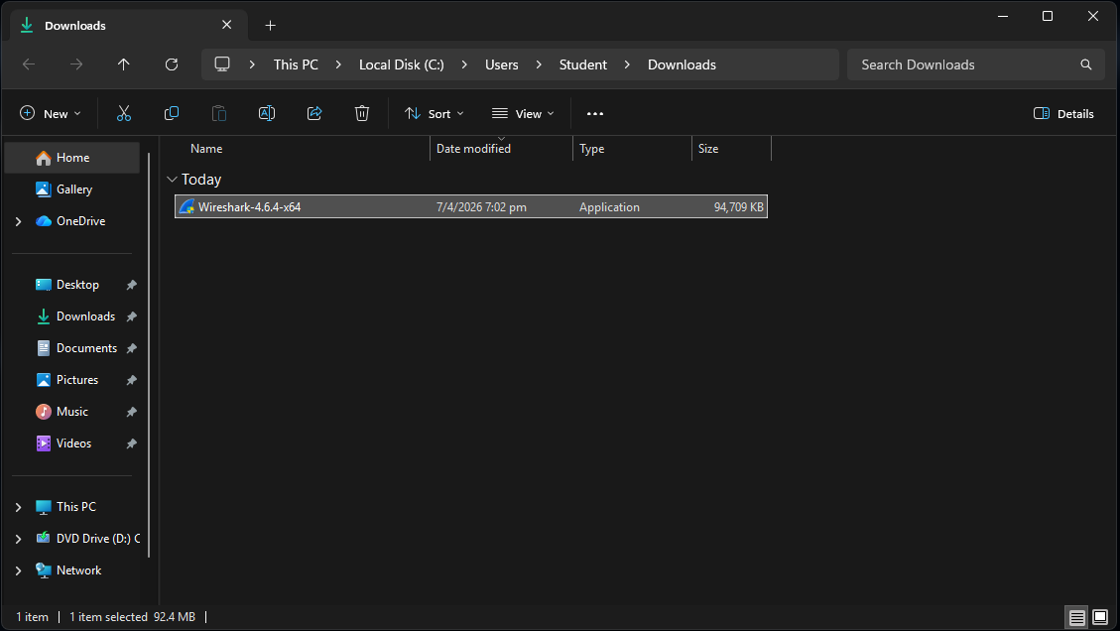
- Click yes if you are being prompted with User Account Control.
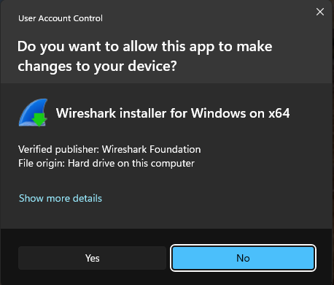

- Click Next and Noted to proceed to the Choose Components page in the installation setup

- Only select Wireshark and TShark on the Choose Components page and click Next.
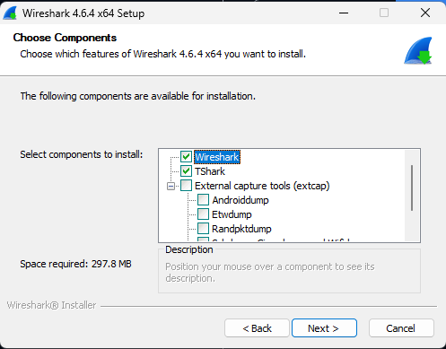
- Click Next and Install to complete the installation of Wireshark. (Note: You will be prompted to install another tool called Npcap. When prompted, click Next and Install to install it as you will need that tool to capture network packets.
- Complete the installation and proceed to the next exercise

Exercise 6.2 Capture HTTP Traffic
- Run the Wireshark Packet Analyser from your Windows Operating System.
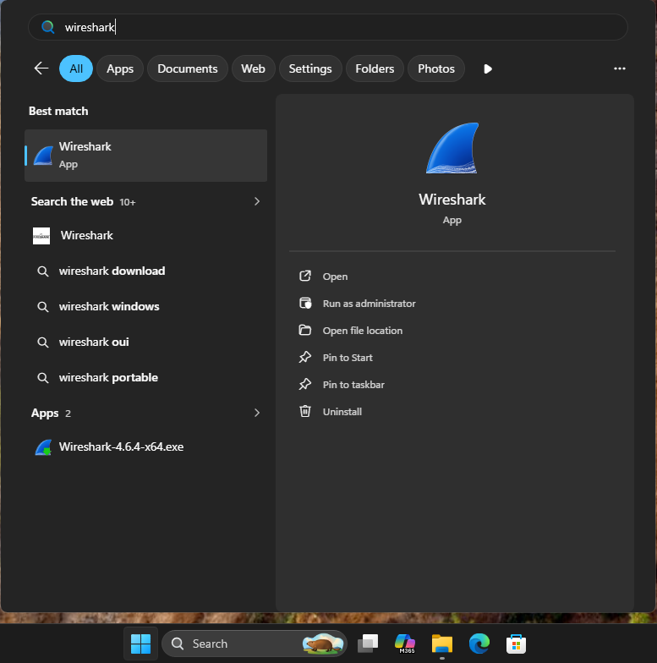

- Double click on the interface of the NIC used to access the internet. (Note: You can identify your active interface by looking at the wavy lines which represents your network activity).
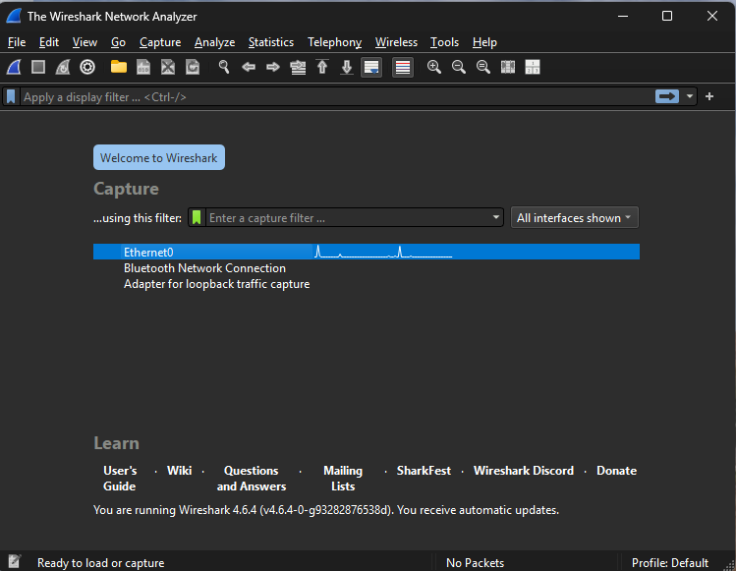
- Once Wireshark has started in network traffic monitoring mode, open your web browser (Microsoft Edge or Google Chrome) and browse to the web page http://httpforever.com/.
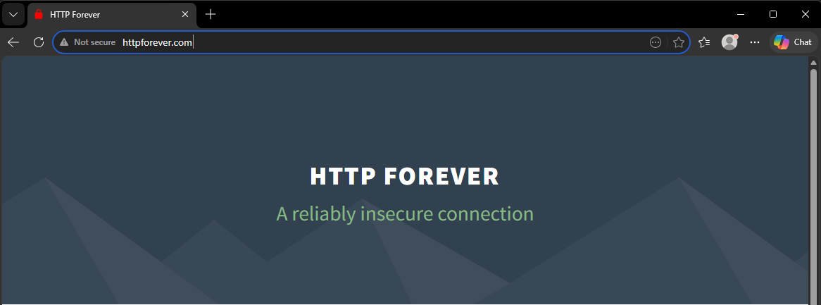

- Stop network traffic monitoring by clicking the red stop icon on the top left of the Wireshark program.
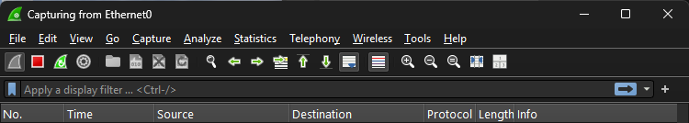

Exercise 6.3 Analyse HTTP Traffic
- Observe the traffic capture in the Wireshark program. To view only HTTP traffic, you can type tcp.port==80 or http in the filter box of the Wireshark program.
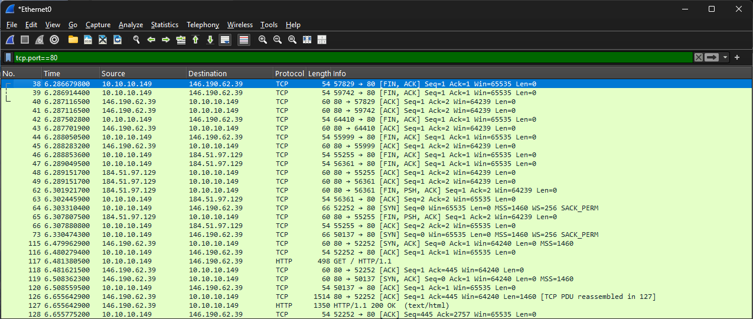
Filter box
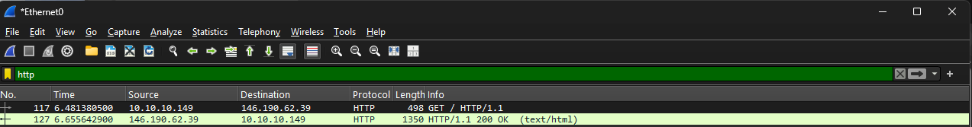
Filter box

- Select any HTTP packet labelled GET / HTTP/1.1. Observe the packet details in the Wireshark packet details panel. (Note: On the packet details, notice the different properties of the packet, such as Frame 117, Ethernet II, Internet Protocol Version 4, Transmission Control Protocol, Hypertext Transfer Protocol).
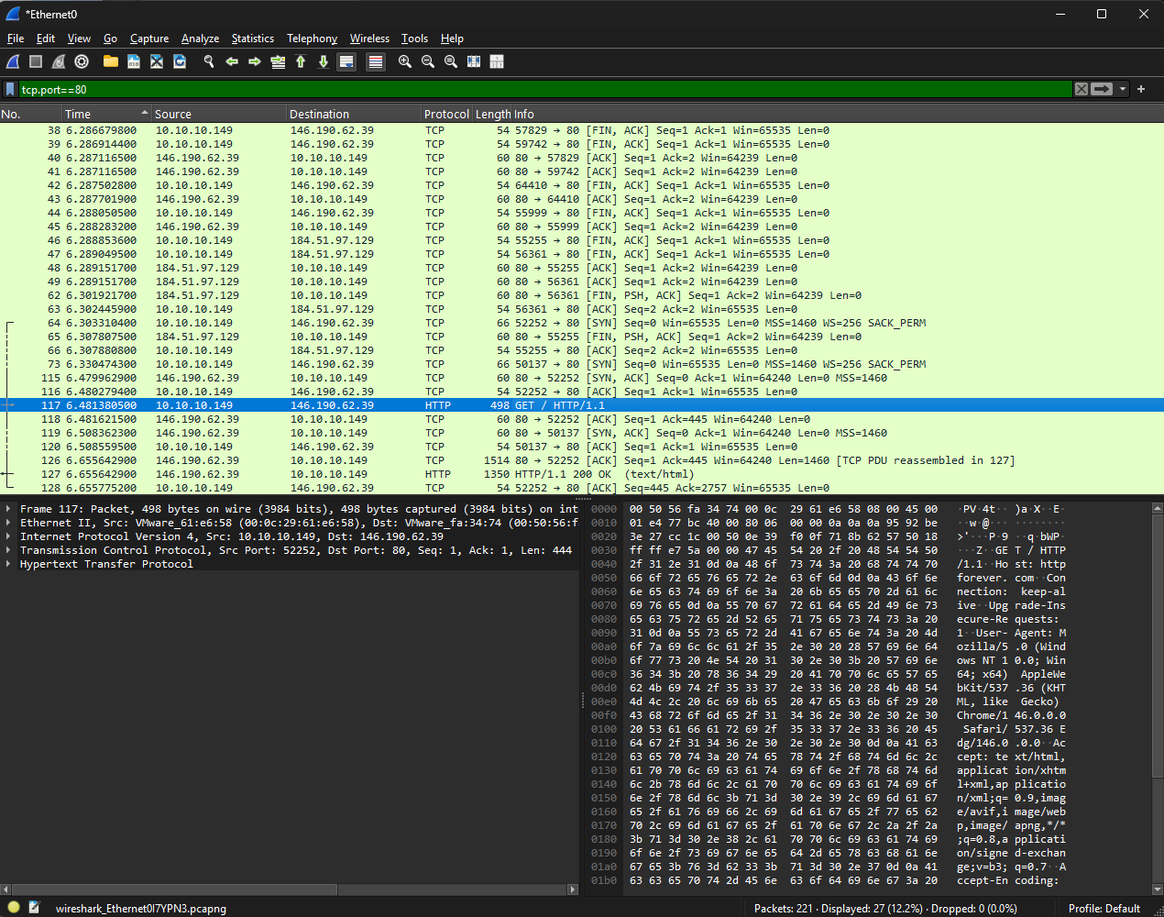
Wireshark Packet Details Panel
- Observe the HTTP request by expanding “Hypertext Transfer Protocol” on the properties panel.
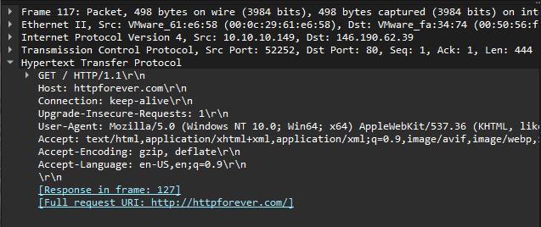

- Now locate the HTTP Response by searching for the next packet labelled HTTP/1.1 200 OK.
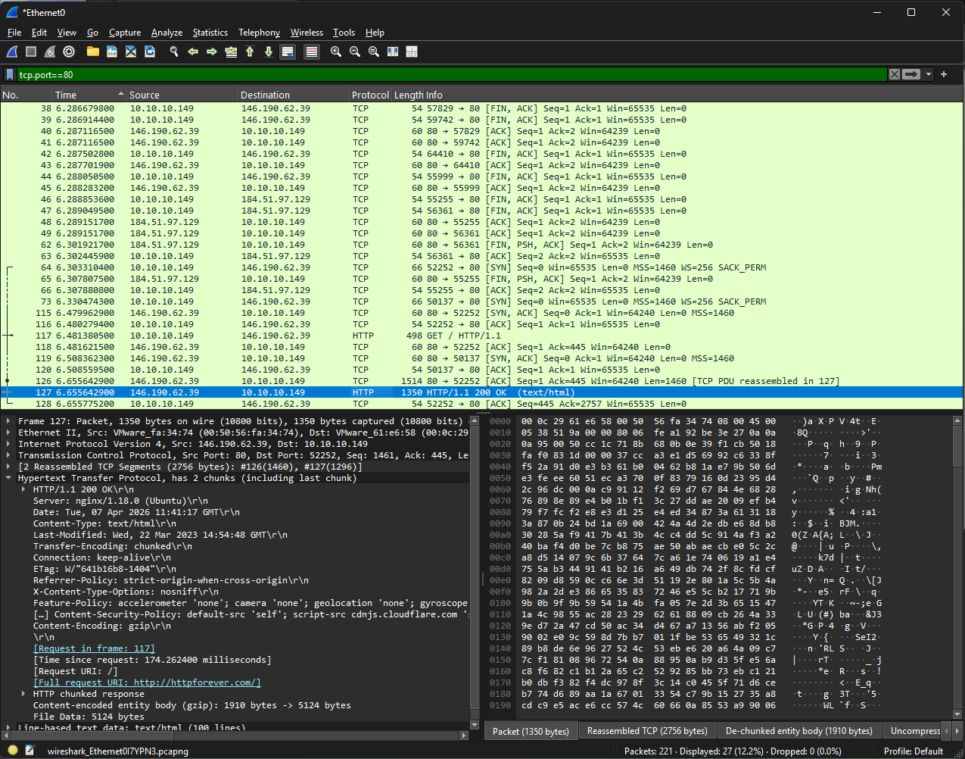
- Examine the HTTP packet properties.
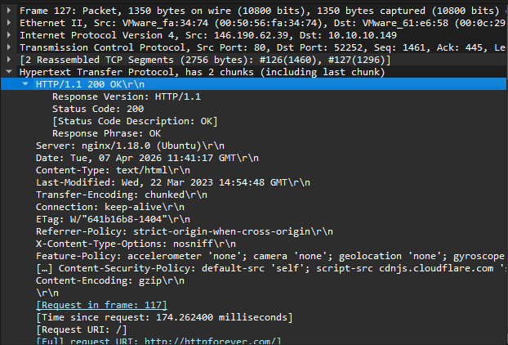

Question: What is the response code for the HTTP request?
200 OK

- Start network traffic monitoring by clicking the Blue Fin Icon on the top left of the Wireshark program.
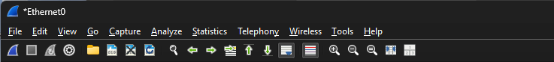
- Once Wireshark has started the network traffic monitoring mode, open your web browser (Microsoft Edge or Google Chrome) and browse to the web page http://www.msftconnecttest.com/connecttest.txt.
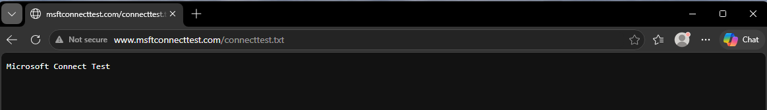
- Stop network traffic monitoring by clicking the red stop icon on the top left of the Wireshark program.

- Locate and examine the HTTP request labelled GET /connecttest.txt HTTP/1.1
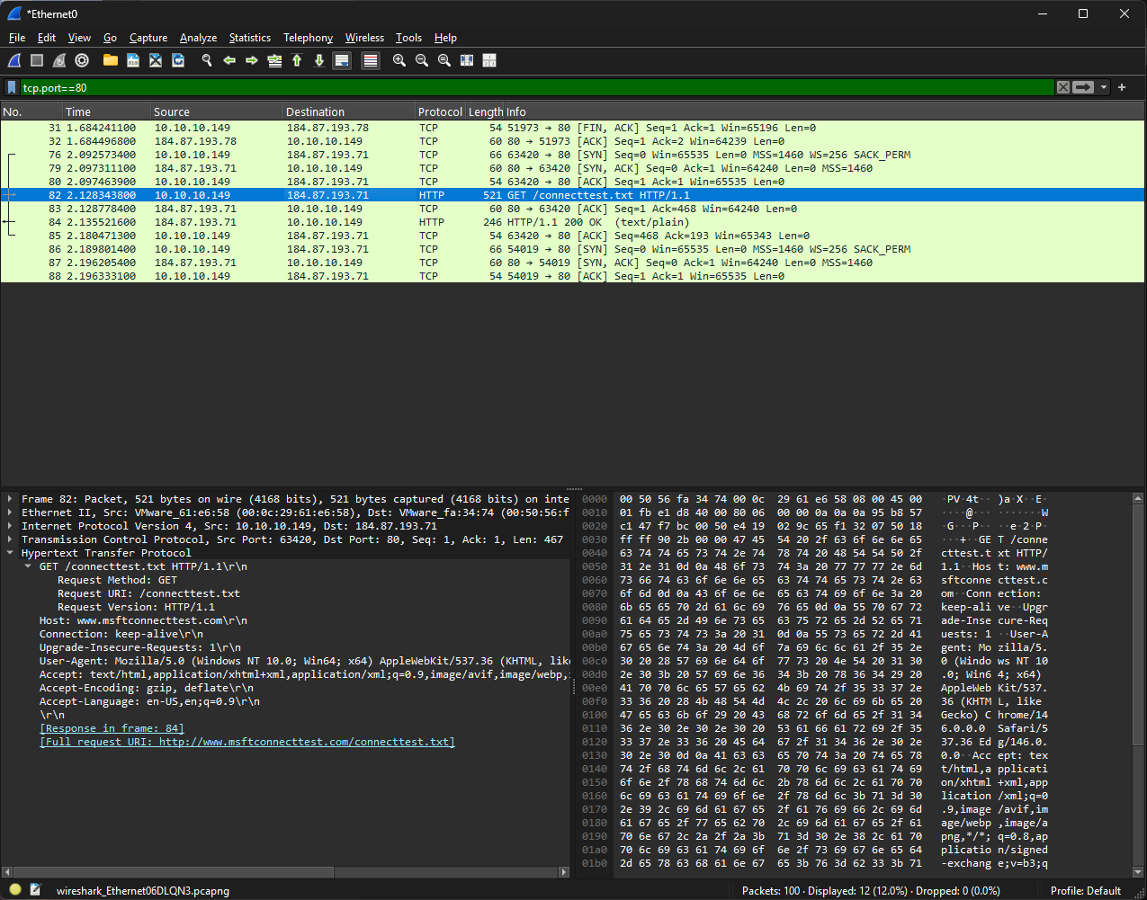

Question: What resource (file) is the browser requesting for?
TXT file

Question: Based on the packet detail panel of the GET request, fill in the following information:
Request Method | GET
Request URI | /connecttest.txt
Host | www.msftconnecttest.com
User-Agent: | Mozilla/5.0 (Macintosh; Intel Mac OS X 10_15_7) AppleWebKit/605.1.15 (KHTML, like Gecko) Version/26.5 Safari/605.1.15

Exercise 6.4 Analyse TCP Packet containing http Traffic
- Repeat Step 21 to locate and examine the HTTP request labelled as
GET /connecttest.txt HTTP/1.1 and expand the Transmission Control Protocol section.
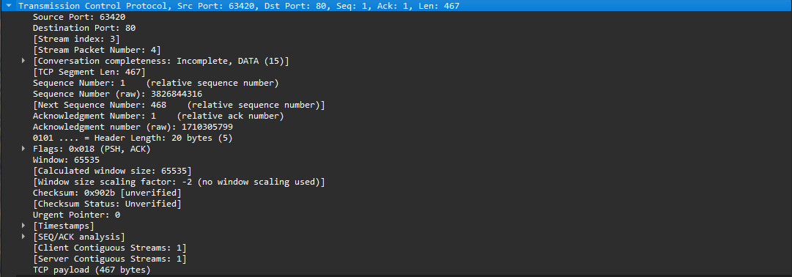
Question: What is the source and destination port number?
Source Port Number | 55120
Destination Port Number | 80

- Repeat Step 21 to locate and examine the HTTP request labelled GET /connecttest.txt HTTP/1.1 and expand the Internet Protocol Version 4 section.
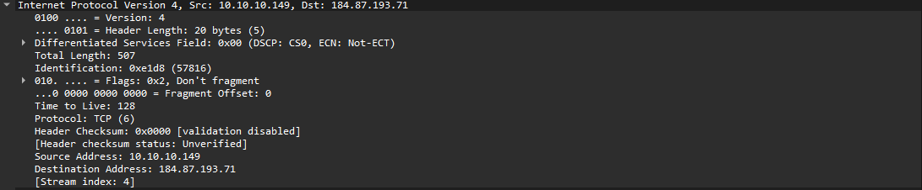
Question: What is the source and destination IP address?
Source IP Address | 172.28.44.92
Destination IP Address | 223.223.168.72

- Repeat Step 21 to locate and examine the HTTP request labelled GET /connecttest.txt HTTP/1.1 and expand the Ethernet II section.
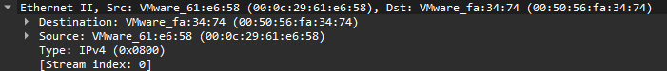
Question: What is the source and destination MAC address?
Source MAC Address | 76:31:3d:e2:a4:f2
Destination MAC Address | 42:ec:f7:ee:d7:2f

----- End of Practical -----

